Chairman: Councillor Simon Hanes | Clerk: Mrs Arin Spencer
Tel: 07484 619582 / Email: kempleyparishclerk@gmail.com
Website: www.kempleyparishcouncil.org

MINUTES OF THE MEETING OF KEMPLEY PARISH COUNCIL
Held at Kempley Village Hall on Tuesday 2nd April 2019 at 19:30

Present: Cllr Simon Hanes (Chairman), Cllr Howell Rees (Vice-Chairman),
Cllr Robin Bennion, Cllr Martin Brocklehurst (MB), Cllr Neil Dransfield (NJD)
In attendance: Mrs Arin Spencer (Clerk)
Alison Robinson (CEO Gloucestershire Association of Parish and Town Councils)
001/19 | To RECEIVE apologies for absence
Resolved: | Received apologies from Cllr Liz Daykin and Cllr Bob Earll.
002/19 | To RECEIVE declarations of interest or requests for dispensations
 | Councillors are asked to declare disclosable pecuniary interests and other interests in items on the agenda as required by the Kempley Parish Council Code of Conduct for Members and by the Localism Act 2011.
Resolved: | None given.
003/19 | Chairman’s Announcements
Resolved: | The Chairman advised those present that while a public participation session forms part of the agenda, this does not preclude members of the public from speaking at other times during the meeting subject to Standing Order 3(e)-(k).
004/19 | To SIGN as a correct record the minutes of the meeting held on 5 March 2019 (previously circulated)
Resolved: | Regarding minute 228/19, it was brought to the Clerk’s attention that the 4th June meeting was omitted from the meeting schedule and the 5th November meeting reads 5th October. Clerk to correct the minutes accordingly.  That, subject to the correction above, they are a true record of the decisions made. | Clerk
005/19 | Public Participation
 | None
006/19 | To DISCUSS the Community Spirit section of the Community Led Action Plan
1  i  ii  iii  iv  v  2  i  ii  iii  iv  v  3  i  ii  iii  iv  v  4  i  ii  iii  iv  v  5  i  ii  iii  iv  v  6  i  ii  iii  iv  v | Discussion to be limited to 45 minutes and have the purpose of getting a collective view on progress to date and further action to be taken.  Council should aim to provide clarity on the following five points:  - Required outcomes  - Key members and other stakeholders  - Timescale, especially an end date  - Monitoring and reporting  - Resources and budget  Community Led Action Plan: Community Spirit Appendix 1  Neighbourhood Watch  Required outcomes:  Maintain neighbourhood watch scheme  Key members and other stakeholders:  Key member – to be appointed once new council has been elected  Arin Spencer – volunteer neighbourhood watch co-ordinator  Timescale and end date:  Scheme is operational and ongoing.  Monitoring and reporting:  Key member (once appointed) to liaise with volunteer co-ordinator and report back to council at regular intervals on neighbourhood watch activities.  Resources and budget:  Neighbourhood watch signs will need to be replaced in due course. Clerk to find out cost of replacing the signs and advise Council so that this can be budgeted for in the next financial year.  A councillor mentioned that a neighbourhood watch sign is partially obscured by a walker sign on the Much Marcle Road. Clerk to investigate.  Pastoral Care  Pastoral care is an ancient model of emotional and spiritual support that can be found in all cultures and traditions. Pastoral care consists of helping acts directed towards the healing, sustaining, guiding, reconciling and nurturing of persons whose troubles and concerns arise in the context of daily interactions.  Required outcomes:  Support pastoral care for the vulnerable members of our community.  Parish Council can do this by  - supporting relevant voluntary or charity groups that benefit the community  - collating and sharing information about local support services  - investigating what services or support Forest of Dean District Council offers in respect of social isolation, dementia, social prescribing, etc.  - finding out if Gloucestershire County Council will offer support for putting technology in place to help vulnerable members of the community.  Key members and other stakeholders:  Parochial Parish Council  Key member – to be appointed once new council has been elected.  Timescale and end date:  Ongoing  Monitoring and reporting:  Key member (once appointed) to review and report to Council at regular intervals.  Resources and budget:  To be considered when draft budget for 2020/21 is discussed in November 2019.  Skills register  Required outcomes:  Create and maintain a skills register. (A list of skills available in the village that people are willing to share).  Key members and other stakeholders:  Key member – to be appointed once new council has been elected.  Timescale and end date:  Council recommends 6 months (due end October 2019)  Monitoring and reporting:  Key member (once appointed) to review and report to Council at regular intervals.  Resources and budget:  None required.  Community Emergency Plan  Required outcomes:  Review and keep Community Emergency Plan updated  Key members and other stakeholders:  Key member – to be appointed once new council has been elected.  A member of the community should be sought to support this function.  Timescale and end date:  Immediate review. Ongoing thereafter.  Monitoring and reporting:  Key member (once appointed) to review and report to Council at regular intervals.  Resources and budget:  None required.  Community Well Being Agent (previously Village Agent)  Required outcomes:  Maintain contact with Community Well Being Agent  Key members and other stakeholders:  Key member – to be appointed once new council has been elected.  Timescale and end date:  Ongoing  Monitoring and reporting:  Key member (once appointed) to make contact with Community Well Being Agent and report to Council at regular intervals.  Resources and budget:  None required.  Village Hall  Required outcomes:  Fundraise for refurbishment.  Undertake a feasibility study for Public Works Programme loan. (Complete)  Key members and other stakeholders:  Key member – to be appointed once new council has been elected.  Timescale and end date:  No further action can be taken until Kempley Village Hall Trust submits an application for grant funding.  Monitoring and reporting:  Key member (once appointed) to represent Council on the Kempley Village Hall Trust and report back to Council at regular intervals.  Resources and budget:  Unknown. No grant application has been submitted by Kempley Village Hall Trust. | Clerk  Clerk  KVHT
007/19  Resolved: | To AGREE a date for the Annual Parish Meeting  This must take place between 1 March and 1 June 2019.  Date for the Annual Parish Meeting provisionally set for 30 May 2019.
008/19  Resolved:  009/19  Resolved: | Planning  Application ref: P0271/19/AG  Application address: The Moor House, Fishpool GL18 2BT  Proposal: Prior notification for the erection of an agricultural building for the storage of agricultural machinery.  Link to full details: https://publicaccess.fdean.gov.uk/online-applications/applicationDetails.do?activeTab=summary&keyVal=PN6EJBHI01000  Comments: Council is asked to advise if further information is required in respect of the above prior notification. Deadline for such a request is 3 April 2019.  No request for further information.  Public Path Diversion and Extinguishment Orders at Kempley Court, Kempley (P1689/18/FUL)  Council discussed the diversion and extinguishment orders. Appendix 2.  To object to the stopping up of footpath GKE 18 Q-R.  Clerk to draft a letter to the Public Rights of Way Officer summarising Council’s comments on the proposed diversion and extinguishment orders. | Clerk
 | Financial Management
010/19  011/19 | RECEIVED a report from the Lead Member for Finance, Cllr Howell Rees, on his internal examination of the accounts for the period 1 December 2018 – 31 March 2019. Appendix 3.  Expenditure incurred since the Parish Council meeting on 5 March 2019:  Payment Details Cheque Amount Power  1&1 IONOS MyWebsite (Feb-May) 388 £ 17.96 LGA 1972 s111  SLCC CiLCA Registration (Training) 389 £ 350.00 LGA 1972 s111
Resolved: | Approved the above expenditure.
012/19 | Bank Reconciliation
Resolved: | Noted and signed the year end bank reconciliation dated 31 March 2019.
013/19 | Asset Register  To RECEIVE asset condition report as at 28/03/2019  To NOTE updated asset register.
Resolved: | Deferred to next meeting as condition report and asset register were not available.  A councillor suggested that the Neighbourhood Watch signs should be on the asset register along with the 20 is Plenty road signs as these have been paid for by Council and will at some point need to be replaced. Clerk to investigate replacement cost and update asset register accordingly. | Clerk
 | Website
014/19 | To CONSIDER migrating the Kempley Parish Council website to a WordPress site hosted and managed by 1&1 IONOS at a cost of £86.40 per year (for the WordPress Essential package). See Appendix 4.
Resolved: | To migrate www.kempleyparishcouncil.org to 1&1 IONOS WordPress Essential at a cost of £86.40 per year.  Proposed by Cllr Dransfield. Seconded by Cllr Hanes. Nem con.  Clerk to rebuild the website in WordPress at an hourly rate of £10 up to a maximum of £150.  Proposed by Cllr Dransfield. Seconded by Cllr Rees. Nem con. | Clerk
015/19 | Clerk’s Report  Action Tracker
Resolved: | Noted the Action Tracker prepared by the Clerk. Appendix 5.  Council discussed information required regarding the Village Green. Cllr Dransfield agreed to send a list of questions to the Clerk for further investigation. | NJD/ Clerk
Resolved: | Council asked the Clerk to set a reasonable timescale and end date for all items on the action tracker for presentation to Council at the next meeting.  Clerk’s Salary  Noted adjustment of Clerk’s salary to SCP 8 £10.37/hour in line with pay scales agreed by the National Joint Council for Local Government Services (NJC) published by NALC on 7 December 2018. | Clerk
016/19 | Notice of items to be taken into consideration at the next meeting in May
Councillors highlighted the following items:
Appointment of Jeff Manns to cut the grass and trim hedges on the village green.
Clerk recommends:
Election of Chairman (LGA 1972 ss 15 & 34)
Election of Vice-chairman
Councillors to sign Acceptance of Office (LGA 1972 s 83)
Appointment of Committee Members (LGA 1972 s 101-106 and schedule 12)
- Staffing Committee
Appoint a representative for the following:
- Village Hall
- Neighbourhood Watch
- Community Emergency Volunteer
Review of delegation arrangements to Committees
Review and adoption of Parish Documentation
Update of Bank Signatories
Insurance review
017/19 | Next Meeting
 | The Annual Parish Council Meeting will take place on 7th, 8th or 15th May 2019 at 7:30pm in Kempley Village Hall. Date to be confirmed subject to availability of all three Councillors nominated for election on 2 May 2019.
Schedule of meetings and topics for discussion:
Meeting Date Key Tasks / Topics
??/05/2019 Annual Parish Council Meeting
- Policy review
- Insurance review
- Approve annual governance statement and accounts
04/06/2019 Discuss CLP Action Points – Environment
Possible co-option if insufficient candidates at May election
02/07/2019 Discuss CLP Action Points – Communication
06/08/2019 Discuss CLP Action Points – Planning for the Future
03/09/2019 Appoint independent internal auditor
First consideration of projects to be included in new budget
01/10/2019 Committees to consider their budgets
05/11/2019 First draft of budget for council to consider
The Chairman thanked all for attendance and with no further business closed the meeting at 20:45pm.

Signed Date

Print Name
Appendix 1
ACTION TO BE TAKEN | POTENTIAL PARTNERS | PRIORITY FOR ACTION
COMMUNITY SPIRIT
AIM: Increased community cohesion
Maintain neighbourhood watch scheme | Volunteer | High Start ASAP
Support pastoral care for the vulnerable members of our community | PCC, KPC | High Ongoing
Create and maintain a skills register | Village Group Reps | Medium Start by end 2017
Review and keep Community Emergency Plan updated | KPC | Medium Biannual review
Maintain contact with Community Well Being Agent | KPC | Low Ongoing
AIM: To ensure village hall is made fit for purpose
Develop the refurbishment plan | KVHT, PCC | High 2017
Fundraise for refurbishment | KVHT, KPC, DC & KPM | High Ongoing
Undertake a feasibility study for Public Works Programme loan | KPC, KVHT | High Complete
Extend activities within the village hall | KVHT | Medium Ongoing

Appendix 2
Appendix 3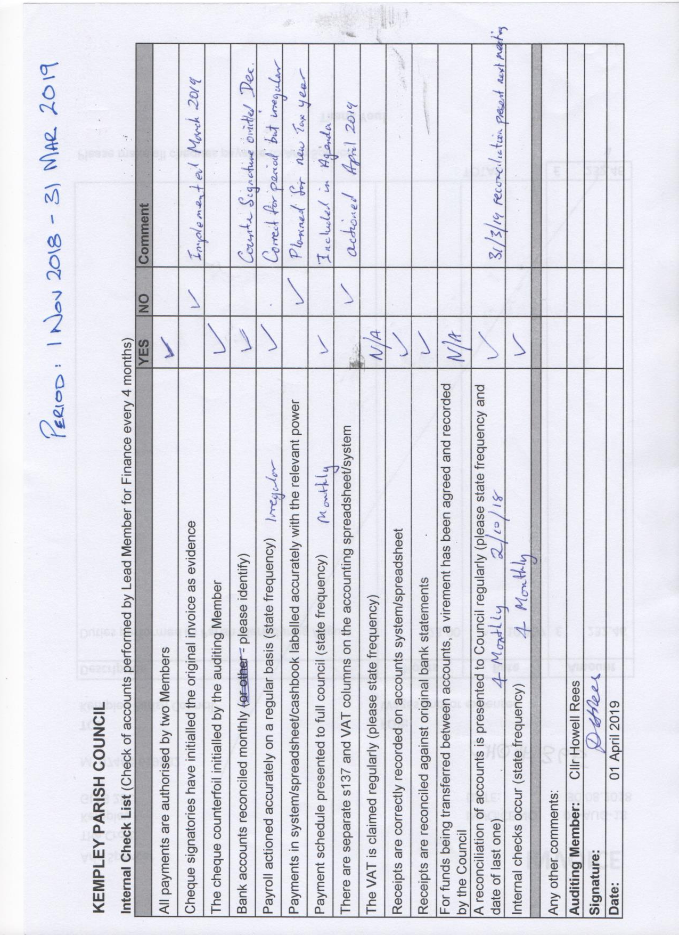
Appendix 4
Report: Website Hosting Upgrade
By Arin Spencer (Clerk)
25 March 2019

Introduction
The Kempley Parish Council website (the ‘website’) is hosted by 1&1 IONOS. The package includes hosting, storage space of 50Mb and a website builder interface that makes it possible to update the website without coding experience.
The website builder currently in use was released in 2010 and is out of date. The website is utilising 44Mb of its 50Mb storage space and some data has had to be removed from the site for it to remain functional.
A website builder (construction) and hosting (storage) upgrade is needed if the website is to continue to function properly and grow as required.

Investigation
The following website builder options were trialled:
- Wix
- GoDaddy
- 1&1 IONOS
The following managed WordPress options were investigated:
- BlueHost
- WordPress.com
- GoDaddy
- 1&1 IONOS
The most user friendly and cost-effective options to emerge from the above were 1&1 IONOS Website Builder and 1&1 IONOS managed WordPress. These are both compared with the current package in the table below:

 | 1&1 Ionos  Current Package | 1&1 Ionos Hosting:  WordPress Essential | 1&1 Ionos  Website+ Business
Annual Cost | £ 71.84/year incl VAT | £7.20 for 1st 6 months then £86.40/year | £12 for 1st year and £144/year thereafter
Domain | £19.32/year incl VAT | Included | Included
Support | Email, live chat, phone | Email, live chat, phone | Email, live chat, phone (only for hosting)
Design Customisation | Basic 2010 version, now out of date | Advanced | Advanced
Storage | 50Mb | 25GB | Unlimited (based on reasonable use)
SSL Certificate | Included | Included | Included

1&1 Ionos Website+ Business
The benefits of this package are an easy to edit and quick to respond interface. Increased design customisation and 24/7 support.
The drawbacks are that the website will need to be completely rebuilt (but this is also true for any other upgrade option) and an increase of 58% in the running cost of the website.

1&1 IONOS WordPress Essential
WordPress.org is the world’s most popular website building platform (28% of all websites are powered by WordPress). The open source software is available free from WordPress.org but requires an experienced website builder to set up a self-hosted site.
To make WordPress accessible to beginners, there are numerous companies that offer hosted and managed WordPress packages with an easy to use WordPress setup wizard and automatic updates.
The benefits of the 1&1 IONOS managed WordPress option are 25GB of storage space and a slightly lower annual cost than what is currently being paid.
The drawbacks are a slightly less intuitive and user-friendly design interface, and no website building technical support (only hosting support).

Website Rebuilding Costs
To rebuild the website 1&1 IONOS would charge £250 for the first five pages and £25 per page thereafter. The website currently has 27 pages so the cost would be £800. This offer is only for migration to the 1&1 IONOS Website+ Business package.
Indications are that the cost to build the website in WordPress would be £600-£700.

Summary
The Kempley Parish Council website has outgrown its entry level hosting package and needs more storage space.
An easy to use website builder is needed so that the website can be built and updated without the need for coding expertise.
The website will need to be rebuilt regardless of which upgrade option is chosen. A professional will charge approximately £600 - £700 to do this.¹

Recommendation
The Clerk recommends Council consider rebuilding the website using the 1&1 IONOS WordPress Essential managed hosting package at a total cost of £1.20/month for the first six months and £7.20/month thereafter.
This option provides ample storage space (25GB), a free domain, adequate technical support, and a platform with advanced design customisation capability.

¹ The Clerk estimates it would take her 15 hours to rebuild the site in WordPress.

Appendix 5
Action Tracker (FOR INFORMATION ONLY)
Minute Ref | Details | Due Date | Status | Action
227/19  05.03.19 | Gigaclear status update | None | Pending | Clerk to report back
227/19  05.03.19 | Delivery of election flyer to residents not on mailing list. |  | Pending | Clerk to deliver flyers by hand on 29 March
222/19  05.03.19 | Free First Aid Course for parishioners | None | Pending | Clerk to arrange
221/19  05.03.19 | Digital Mapping – report on trial | None | Trial in progress | Clerk to report back to Council on trial
218/19  05.03.19 | Village Hall Report (New) | ASAP | In progress | Clerk to produce new report incl NALC advice.
167/18  04.12.18 | Management plan for environmental assets of Village Green | None | In progress | Clerk to complete
156/18  04.12.18 | Internal Audit | 30.04.19 | Pending | Clerk to arrange for 2nd half April
156/18  04.12.18 | Response to TwoRivers re removal of shared boundary hedge | None | Pending | Holding letter sent. Follow up cannot be sent until status of boundary is clear.
149/18  06.11.18 | Highways Note | None | Pending | Clerk to complete
148/18  06.11.18 | Village Green Note | None | In progress | Clerk to complete
128/18  06.11.18 | Kempley House – query re planning permission | None | Pending
115/18  02.10.18 | Join Dementia Action Alliance | None | Pending | Clerk to action.
60/18  19.07.18 | Data Audit | ASAP | In progress | Clerk to complete

