MINUTES OF THE MEETING OF KEMPLEY PARISH COUNCIL
Held at Kempley Village Hall on Tuesday 7th January 2020 at 19:30pm

Present: Cllr Martin Brocklehurst (Chairman), Cllr Dave Lewis (Vice-Chairman), Cllr Tom Jackson (Snow Warden)
In attendance: Mrs Arin Spencer (Clerk) and Jeff Wheeler (Cheltenham Motor Club)
- Apologies for absence. None received
- Declarations of interest and requests for dispensation
Councillors were asked to declare disclosable pecuniary interests and other interests in items on the agenda as required by the Kempley Parish Council Code of Conduct for Members and by the Localism Act 2011.
None received.
- Public Participation
Members of the public were invited to raise questions about and/or comment on items on the agenda. Time for this session was limited to 15 minutes and 5 minutes per individual. Standing Order 3(e)-(k).
Jeff Wheeler, Event Organiser and Resident Liaison Officer for Cheltenham Motor Club, spoke to Council about the Three Shires Stages Rally which took place in September 2019. The event organisers were advised by MotorSport UK to notify the parishes directly on the route which is why Kempley was not informed about the road closures in advance.
This was the third event of its kind to take place in England since the passing of a new law at the end of 2017 allowing the closure of roads for motorsport events.
The Three Shires Stages Rally was, Mr Wheeler said, generally well received and the event will be taking place again this year on Sunday 6 September 2020. He pointed out that only one motorclub can close roads in any particular area per year.
How the consultation process works:
Cheltenham Motor Club discuss the event with parish and county councils on the route. They liaise with emergency services in each area. In January/February MotorSport UK consults formally with all councils on the route. The application for road closures needs to be in by 6 March as the permit must be in place six months prior to the event. Once the permit is issued Mr Wheeler visits every property on the route in person to inform residents about the event and answer any questions.
This year 120 participants are expected to take part, released at 30 second intervals and completing two laps of the route.
Two weeks before the event properties on the route will be sent a ‘Residents Handbook’ containing all necessary information about the event. Mr Wheeler will provide a copy of this to Kempley Parish Council when it is sent out.
At the same time the route will be revealed to participants. The day before the event participants may drive the route to make safety notes. This is done in a normal vehicle and at normal speeds. Any participants practicing in the area and/or driving at speed in the area prior to the event can be reported to the organisers and will be automatically excluded from the event.
Responding to a question about investment in the local road network, Mr Wheeler advised council that the organisers had paid a hefty sum to Gloucestershire County Council for closure of the roads and it would be up to Highways to invest that back into the road network. He also clarified that any specific damage caused by vehicles during the event would be covered by their £67 million liability insurance.
- Minutes
Approved and signed as a correct record the minutes, previously circulated, of the meeting held on 1 October 2019.
- Clerk’s Report (For information ONLY)
Council asked the clerk to provide a list of outstanding action items from the minutes.
Action: Clerk to prepare list of outstanding action items and send to councillors.
The clerk was asked about the maintenance of the flagpole which is still to be arranged. Cllr Jackson offered to paint the flagpole when the weather is suitable.
Action: Cllr Jackson to paint the flagpole. Clerk to arrange for replacement flagpole accessories where necessary.
Action: Clerk to send a list of council assets to Councillors.
- Casual Vacancies
No applications received.
- Budget 2020/21
  - Resolved: Approved the proposed budget for 2020/21.
  - Resolved: To set the precept for 2020/21 at £5748 (£44 per band D property).
- Footpaths and Public Rights of Way
Council discussed the proposed footpath diversions at Court Farm, Kempley including the proposed realignment of the Daffodil Way.
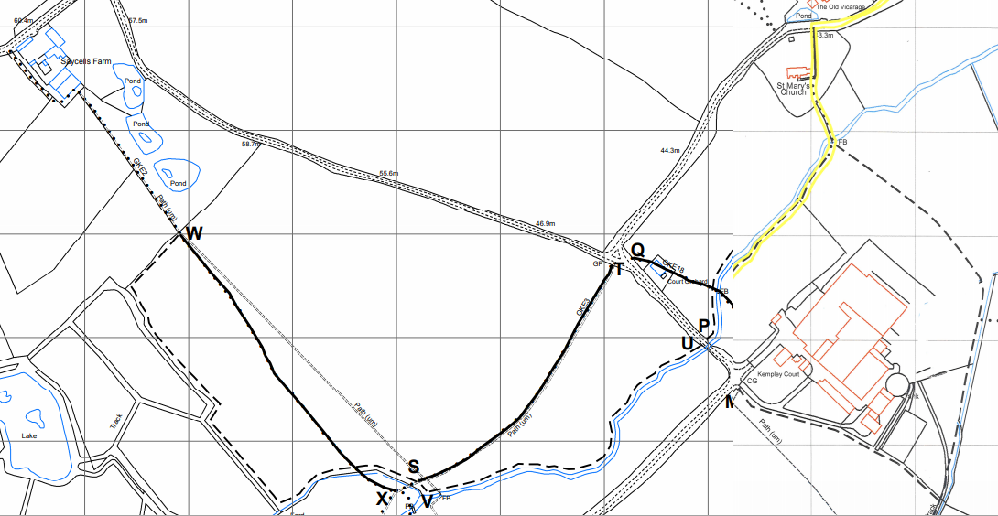
Proposed paths to be extinguished.
Proposed realignment of Daffodil Way
The following observations were made:
- The default position of the Open Spaces Society (OSS) is to ‘oppose a path change unless there is clear public benefit.
Local Councils should generally oppose any proposed path changes when the definitive route is obstructed, cropped or illegally ploughed, and require that the path be put and kept in good order for at least a year before considering the change.’
- Regarding extinguishment orders, the OSS advises Local Councils to ‘be cautious about an application to close a route which is said to be very similar to a nearby route. Often two routes close together provide a useful circular walk, or an alternative route when conditions are muddy.’
- Regarding diversion orders the OSS recommends Local Councils ‘positively oppose these unless the alternative path to be provided either positively improves the route or offers an alignment which is only marginally less satisfactory to users.’
- Regarding realignment of the Daffodil Way along Kempley Brook, it was suggested that the farm might consider putting in a discretionary route along the river (V-U) to test its suitability whilst maintaining the current route. If the diversion was a success and found to be preferred by walkers council could then support the extinguishment order (S-T).
- It was suggested that the second diversion from Saycells Farm to Kempley Brook from a cross field path (W-X) to a headland path (W-S) offers no benefits to walkers and based on the OSS guidance should be opposed.
Action: Council to arrange to meet with the owner of Court Farm to try and find a solution that works for all interested parties.
- Planning
  - Noted the following planning decisions:
    - P1384/19/AG Court Farm, Kempley, GL18 2AT
Prior notification for the erection of a steel portal frame building.
Decision: Approved.
  - Considered the following new planning applications:
    - P1898/19/FUL Court Farm, Kempley, GL18 2AT
Variation of Condition 02 (Approved plans) of planning permission P1689/18/FUL to allow for alterations to the approved roof colour scheme from green to grey.
Resolved: No objections
- Financial Matters
  - Noted Lloyds bank statement dated 31/12/2019 reflecting a balance of £7,164.54
  - Noted Budget Monitoring Statement as at 31/01/2020
  - Resolved: Approved the following payments:
Description | Chq No | Power | Budget | Amount
FoDDC Election Fee | 404 | LGA 1972 s111 | Election | £ 147.00
Staff Salaries (October) | SO | LGA 1972 s112(2) | Staff Costs | £ 207.40
Staff Salaries (November) | SO | LGA 1972 s112(2) | Staff Costs | £ 207.40
Staff Salaries (December) | SO | LGA 1972 s112(2) | Staff Costs | £ 207.40
Staff Expenses | 406 | LG(FP)A 1963 s5 | Staff Costs | £ 118.18
RBL Poppy Appeal | 407 | LGA 1972 s137 | Donations | £ 30.00
GAPTC Training | 408 | LGA 1972 s111 | Training | £ 15.00
Chris Bligh – Noticeboard | 409 | LGA 1972 s111 | General Repairs | £ 26.49
Community Heartbeat Trust | 410 | PHA 1936 s234 | Defibrillator Pads | £ 195.60
  - Resolved: Approved and signed a direct debit instruction for the annual payment of the ICO Registration Fee at an annual cost of £35 per year.
- Items for the next meeting agenda
To set a date for the annual parish meeting
Review of the Community Emergency Plan
Report on internal accounts check to end January
To consider adopting protocol for the Centenary Stone
- Next Meeting
  - Resolved: That the next ordinary meeting of the Parish Council will be held on 3rd March 2020 at 7:30pm in the Village Hall.
With no further business the meeting was closed at 20:49pm.

Signed (Chairman) Date

BUDGET 2020/2021 | BUDGET | YTD Spend | Expected | BUDGET | BUDGET | Notes
EXPENDITURE | 2019/20 | 2019/20 | year end | 2020/21 | 2021/22
Staff Salaries | 2,430 | 2,074 | 2,489 | 2,537 | 2,537 | 1
Staff travel and expenses | 40 | - | - | 97 | 100
Staff Training | 690 | 365 | 402 | 150 | 175
Data Protection Fee (ICO) | 40 | - | 40 | 35 | 35
Meetings - Hall Hire | 180 | - | 135 | 105 | 105 | 2
Internal Audit Fees | 90 | 90 | 265 | 175 | 185
Postage | 15 | 15 | 15 | 18 | 20
Stationery | 10 | - | - | 20 | 25
Printing Costs | 60 | 27 | 50 | 60 | 60
Councillors' Travel | 50 | - | - | - | -
Councillors' Training | 250 | 226 | 566 | 445 | 458 | 3
Insurance | 260 | 251 | 251 | 250 | 255
Subscriptions | 160 | 113 | 113 | 176 | 181 | 4
Election | 325 | 147 | 147 | 100 | 100
LCA Scheme | 100 | - | - | 100 | 130 | 5
Defibrillator Maintenance | 152 | 289 | 289 | 289 | 298 | 6
Annual Parish Meeting | 50 | - | 50 | 50 | 50
Community Survey | 75 | - | - | 75 | -
Village Green Maintenance | 730 | - | 730 | 800 | 824 | 7
General Repairs | 150 | 26 | 150 | 175 | 180
Website | 185 | 94 | 112 | 112 | 115 | 8
Donations | 30 | 30 | 30 | 30 | 30 | 9
General Reserve | - | - | - | 350 | 350
TOTAL EXPENDITURE | 6,072 | 3,746 | 5,833 | 6,149 | 6,213
INCOME
Grants/gifts/s106/CIL | - | - | - | - | -
Bank/investment interest | - | - | - | - | -
TOTAL INCOME | - | - | - | - | -
Requiring funding | 6,072 |  | 5,833 | 6,149 | 6,213
Less use of ringfenced funds | 311 |  | 401 | 401 | 345
Less use of reserves | 550 |  | 221
PRECEPT | 5,211 |  | 5,211 | 5,748 | 5,868 | 19
Balance 31/03/2019 |  |  | 5,108
Expected income: |  |  | 5,211
 |  |  | 10,319
Expected expenditure: |  |  | 5,833
Projected balance on 31/03/2020: |  |  | 4,486
Projected Reserves at 31/03/2020 |  |  | £
Transparency Grant |  |  | 48
Wayleave (ringfenced for defibrillators) |  |  | 802
Election Reserve |  |  | 353
General Reserve |  |  | 3,283
 |  |  | 4,486
NOTES
1. SCP 9 £10.57/hour x 20hrs x 12 months = |  |  | £ 2,536.80 | per annum
2. Work from Home Allowance: £6 x 12 |  |  | £ 72.00
Mileage to Chartered Parishes Meetings x 4 |  |  | £ 24.96
 |  |  | £ 96.96
2. Six ordinary meetings and hall hire for the Annual Parish Meeting at £15 per meeting.
3. Training for 1 new councillor per year at £95 per training session plus
continuous development training budget of £50 per councillor per year.
4. Subscriptions:
Gloucestershire Association of Parish & Town Councils |  |  |  | £ 75.00
Society of Local Council Clerks |  |  |  | £ 41.00
Parish Online |  |  |  | £ 60.00
 |  |  |  | £ 176.00
5. Foundation Standard £100, Quality Standard £130, Quality Gold £150
6. Defibrillator maintenance:
Two sets of pads required every 2 years at £40 per set, one battery required every 4 years
at £225 each. £40 x 6 / 2 years + £225 x 3 / 4 years = £289/year maintenance provision
7. £500 for mowing of the green and pruning of the hedges. £300 for pruning of trees.
8. 1&1 Ionos Managed Wordpress £72, MS Office 365 £20, Antivirus £20
9. Donation to British Legion Poppy Appeal under S137.
10. Year | Precept | Annual Cost per Band D Household |  | Annual Increase | Weekly Increase
2017/18 | £4,074 | £31
2018/19 | £4,889 | £37 |  | £ 6.22 | £ 0.12
2019/20 | £5,211 | £39 |  | £ 1.93 | £ 0.04
2020/21 | £5,748 | £44 |  | £ 4.75 | £ 0.09

