Chairman: Councillor Martin Brocklehurst | Clerk: Mrs Arin Spencer
Tel: 07484 619582 / Email: kempleyparishclerk@gmail.com
Website: www.kempleyparishcouncil.org

MINUTES OF THE ANNUAL MEETING OF KEMPLEY PARISH COUNCIL
Held at Kempley Village Hall on Friday 3rd May 2019 at 6:00pm

Present: Cllr Simon Hanes (Chairman) Cllr Martin Brocklehurst (MB)
Cllr Tom Jackson (TJ) Cllr Dave Lewis (DL)

In attendance: Mrs Arin Spencer (Clerk), two (2) candidates for co-option and four (4) members of the public.

The Annual Meeting was held unusually early due to the nomination of only three councillors all of whom were needed for the meeting to be quorate and 3rd May 2019 being the only date all could attend.

Chairman Simon Hanes opened the meeting, welcomed parishioners and presided over the first item on the agenda.

018/19 | To ELECT a Chairman for 2019/20  Resolved: Elected Cllr Martin Brocklehurst as Chairman.  Nominated by Cllr Lewis. Seconded by Cllr Jackson. Nem con.
019/19 | To RECEIVE apologies for absence
 | None received.
020/19 | To RECEIVE declarations of interest or requests for dispensations
 | Councillors were asked to declare disclosable pecuniary interests and other interests in items on the agenda as required by the Kempley Parish Council Code of Conduct for Members and by the Localism Act 2011.
 | None declared/requested.
021/19 | Chairman’s Announcements
Chairman Martin Brocklehurst thanked outgoing chairman Simon Hanes and, on behalf of the Councillors who have served alongside him this past year, presented Cllr Hanes with a token of appreciation for a remarkable 27 years of service on the Parish Council.

Going forward Cllr Brocklehurst said he wanted to find ways for the Parish Council to formally recognise and show appreciation for the vital role that volunteers play in the community.
022/19 | To APPROVE the minutes  Resolved: Approved and signed the minutes of the meeting held on 2 April 2019 as a correct record of the decisions made.
023/19 | Public Participation
 | A member of the public thanked the new councillors for coming forward to serve on the Parish Council.
024/19 | To APPROVE the following schedule of meetings for 2019/20  Tuesday 4th June 2019 at 7:30pm Tuesday 3rd December 2019 at 7:30pm  Tuesday 2nd July 2019 at 7:30pm Tuesday 7th January 2019 at 7:30pm  Tuesday 6th August 2019 at 7:30pm Tuesday 4th February 2019 at 7:30pm  Tuesday 3rd September 2019 at 7:30pm Tuesday 3rd March 2019 at 7:30pm  Tuesday 1st October 2019 at 7:30pm Tuesday 7th April 2019 at 7:30pm  Tuesday 5th November 2019 at 7:30p, Tuesday 5th May 2019 at 7:30pm  Resolved: Approved the above schedule of meetings for 2019/20.
025/19 | Casual Vacancies  The Clerk advised Council that, as per Arnold Baker (11th Ed, pg 47):  If there are insufficient candidates, those who are and remain validly nominated (if any) are declared elected.  If they constitute a quorum they may fill the remaining vacancies by co-option.  Applications for co-option from David Spencer and John Birt were considered.  Resolved: Agreed the co-option of David Spencer and John Birt.  The co-opted Councillors signed their declarations of acceptance of office and joined the meeting.
026/19  027/19 | Delegation of functions  Resolved: Appointed Cllr David Spencer to represent Kempley Parish Council as a trustee on Kempley Village Hall Trust.  Resolved: Appointed Cllr John Birt as Lead Member for Finance for 2019/20 to perform a quarterly internal check of the accounts.  Cllr Birt was asked to review Financial Regulations. | JB
028/19 | Kempley Charities  Received a report from John Harper on Elizabeth Pyndar’s Charity. (Appendix 1)  Resolved: Appointed Glyn Bennet, Margaret Watkins and John Harper as trustees to Elizabeth Pyndar’s Charity.
029/19 | Annual Governance and Accountability Return 2018/19  Resolved: Certified Kempley Parish Council as exempt from a limited assurance review and signed the Exemption Certificate.
030/19  031/19  032/19 | Noted the Annual Internal Audit Report 2018/19  Resolved: Approved completion of the Annual Governance Statement 2018/19  Resolved: Approved the Accounting Statements for 2018/19.
 | Financial Matters
033/19  034/19  035/19  036/19  037/19 | Council agreed that current bank signatories may continue to authorise payments until such time as a new bank mandate has been arranged.  Resolved: Approved payments as per Cheque Approval Sheet (Appendix 2)  Noted the bank reconciliation dated 29 April 2019 (Appendix 2)  Resolved: Approved and signed Clerk’s salary schedule for 2019/20 (Appendix 3)  Resolved: Appointed Jeff Manns Garden Services to maintain the Village Green for 2019/20 at a cost of £500 for the year.  Council instructed the Clerk to obtain risk and method statements (RAMS), evidence of liability insurance and a contract from Jeff Mans Garden Services. | Clerk
038/19  039/19 | Asset Register  Received asset condition report as at 28/03/2019 (Appendix 4)  Noted and approved the updated asset register. (Appendix 5)
040/19 | Insurance Review  Resolved: Approved renewal of the insurance policy with Community First for 2019/20.  Cllr Spencer was asked to review the insurance to ensure that it continues to meet Council’s needs and provides adequate cover where required. | DS
Planning
No new planning applications received.

041/19 | Clerk’s Report  Fastershire Update  Received from Cllr Martin Brocklehurst  Fastershire through their selected contractor Gigaclear will reach the outskirts of Kempley in the next 1 – 2 months and expect to install fibre optic cables from their Greenway Cabinet along the B4024 to the Parish Boundary. It is currently planned that fibre optic cables from the Greenway Cabinet will not progress any further into Kempley;  The first property in the parish likely to have fibre optics installed to a box outside their property will be 1 & 2 Stonehouse Cottages (GL18 2AR) (confusingly referred to as Oak Cottages by Fastershire);  Installation to the main village is still about 12 months away. Installation for the Parish of Kempley will be from the Kempley Cabinet and it appears access will not come from the Greenway Cabinet or from the B4024.  Free First Aid Course  Organiser is away until 13 May. Will set a date as soon as he is back in the office.  Action Tracker - FOR INFORMATION ONLY (Appendix 6)  Clerk was asked to formulate more realistic timeframes for completion.  Notice of items to be taken into consideration at the next meeting:  Councillors are asked to highlight any items.  The Clerk recommends the following:  Election of Vice-chairman  Appointment of Committee Members (LGA 1972 s 101-106 and schedule 12)  - Staffing Committee  Review and adoption of Parish Documentation  Council elected Cllr Dave Lewis as Vice-Chairman.  Proposed by Cllr Brocklehurst. Seconded by Cllr Spencer. Nem con.  Clerk’s note: this decision will be confirmed at the next meeting as it was not an agenda item for this meeting. | Clerk
042/19 | Next Meeting
 | The next ordinary meeting of Kempley Parish Council will take place on 4th June 2019 at 7:30pm in Kempley Village Hall.
Schedule of meetings and topics for discussion:
Meeting Date Key Tasks / Topics
04/06/2019 Discuss CLP Action Points – Environment
Co-option of two more councillors to fill vacancies
02/07/2019 Discuss CLP Action Points – Communication
06/08/2019 Discuss CLP Action Points – Planning for the Future
03/09/2019 Appoint independent internal auditor
First consideration of projects to be included in new budget
01/10/2019 Committees to consider their budgets
05/11/2019 First draft of budget for council to consider
The Chairman thanked all for attendance and with no further business closed the meeting at 19:09pm.

Signed Date

Print Name
Appendix 1

Kempley Charities Trustees

Annual Report to the Kempley Parish Council
Elizabeth Pyndar’s Charity; The Trustees met in December and two grants were made to worthy individuals. The Trustees also reviewed the objectives and subsequently amended them to meet present day needs including the advancement of community development.
There are four Trustees being the Minister of the Church and 3 appointed by the Parish Council.
Three Trustees are appointed by the Parish Council annually and currently are Glyn Bennett, John Harper and Margaret Watkins. All are willing to be re-appointed for the next twelve months.

John Harper
Trustee and Correspondent
28 April 2019

Appendix 2
KEMPLEY PARISH COUNCIL
Monthly Accounts / Cheque Approval
May 2019 Meeting
Bank Balance at 31 March 2019
Current Account |  |  |  |  | 6,089.68
Less unpresented cheques at 31 March 2019 |  |  |  |  | - 982.14
Plus unpresented cheques at 29 April 2019 |  |  |  |  | 847.92 | 5,955.46
2019/20
Precept |  |  |  |  | 5,211.00
VAT Refund |  |  |  |  | - | 5,211.00
 |  |  |  |  |  | 11,166.46
Expenditure to 29 April 2019
Staff Costs |  |  |  |  | -
Training |  |  |  |  | 350.00
Annual Parish Meeting Expenses |  |  |  |  | -
Stationery & Postage |  |  |  |  | -
Website |  |  |  |  | 17.92
Audit Fees |  |  |  |  | -
Insurance |  |  |  |  | -
Subscriptions |  |  |  |  | -
VAT |  |  |  |  | -
Total Expenditure YTD |  |  |  |  |  | 367.92
 |  |  |  |  |  | 10,798.54
Bank Reconciliation
Closing balance 29 April 2019
Current Account |  |  |  |  |  | 10,798.54
Approval Required May 2019 | Chq No | Power | Budget | Amount | Included in Figures above
Clerk's Salary (April) | 390 | LGA 1972 s111(2) | Staff Salaries | £ 207.40 | No

Appendix 3

KEMPLEY PARISH COUNCIL
CLERK'S SALARY SCHEDULE
Employee: | Arin Spencer
Period: | April 2019 - March 2020
SCP 8: | £10.37 / hour
Employed from: | 29/06/2018
Salary | Hours per month | Hourly Rate | Total
April 2019 | 20.0 | 10.370 | £ 207.40
May 2019 | 20.0 | 10.370 | £ 207.40
June 2019 | 20.0 | 10.370 | £ 207.40
July 2019 | 20.0 | 10.370 | £ 207.40
August 2019 | 20.0 | 10.370 | £ 207.40
September 2019 | 20.0 | 10.370 | £ 207.40
October 2019 | 20.0 | 10.370 | £ 207.40
November 2019 | 20.0 | 10.370 | £ 207.40
December 2019 | 20.0 | 10.370 | £ 207.40
January 2020 | 20.0 | 10.370 | £ 207.40
February 2020 | 20.0 | 10.370 | £ 207.40
March 2020 | 20.0 | 10.370 | £ 207.40
TOTAL | 240.0 |  | £ 2,488.80
Signed: |  | Date:
 | Chairman
Signed: |  | Date:
 | Clerk (Arin Spencer)
Minute Reference:

Appendix 4
KEMPLEY PARISH COUNCIL
Asset Condition Report as at 27 March 2019
Prepared by: Arin Spencer (Clerk)
Asset Description | Location | Condition | Comments | Photographs
Village Green (VG140) | Kempley Green | Good
Bus Shelter | Kempley Green | Good |  | 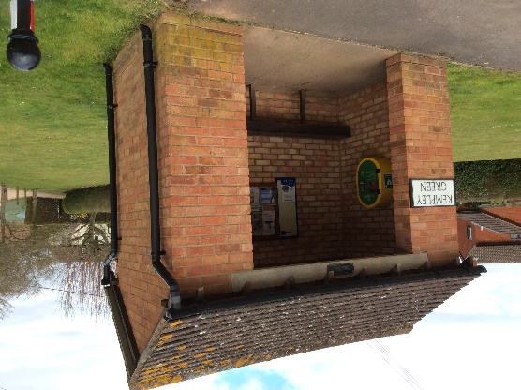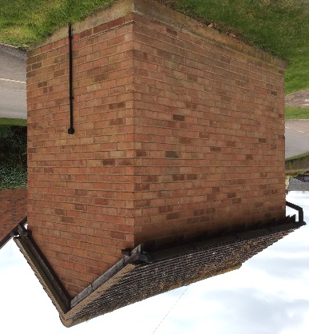
Bus Shelter | Fishpool | Good | Vegetation to back and side needs to be trimmed back. | 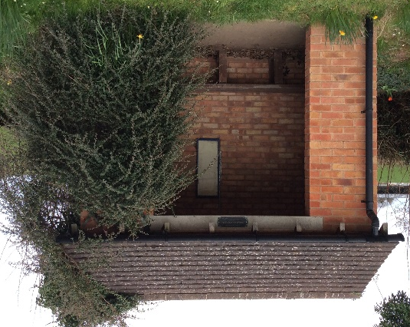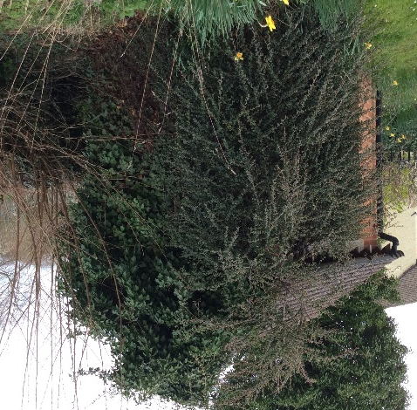
iKiosk | Kempley Green | Good
Defibrillator | Kempley Green | Good | Pads expire:  October 2019
Defibrillator | Village Hall | Good | Pads expire: | Code to open defibrillator not available at time of inspection.
Defibrillator | Fishpool | Good | Pads expire:  October 2019 | 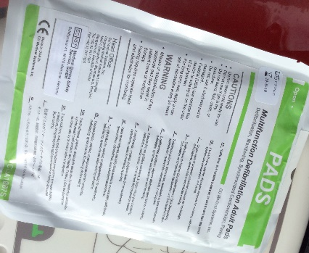
Flagpole | Kempley Green | Poor | Needs to be repainted.
Flags x 2 |  |  | Did not inspect
Noticeboard | Kempley Green Bus Shelter | Good
Noticeboard | Fishpool | Needs replacing |  | 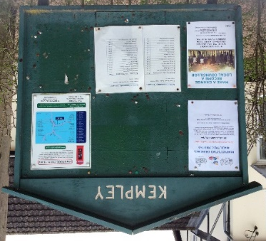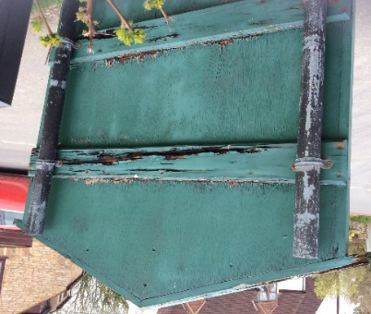
2014 Memorial Stone | Kempley Green | Good |  | 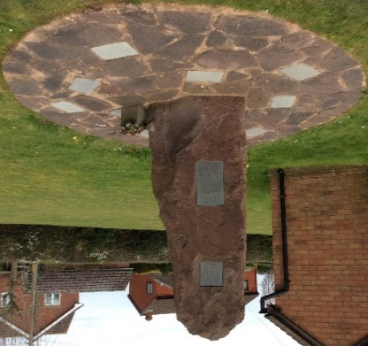
HP Laptop | Serial No:  CND7011671 | Good
Filing Cabinet | 4 drawer lockable filing cabinet | Average
Traffic Signs | 20 is Plenty |  | Not inspected
 | Neighbourhood Watch |  | Not inspected
 | We Live Here | Good

Appendix 5
KEMPLEY PARISH COUNCIL
ASSET REGISTER AS AT 31/03/2019
Description | Identification/Location | Date Acquired | Accounts Value | Insured Value | Custodian | Last Inspection | Condition
Kempley Green | Land Reg cert VG 140 | 19-10-1978 | £ 1.00 |  | KPC | 28-03-2019 | Good
Bus Shelter | Village Green | 31-03-2006 | £ 3,444.00 | £ 3,444.00 | KPC | 28-09-2019 | Average
Bus Shelter | Fishpool | 31-03-2006 | £ 3,444.00 | £ 3,444.00 | KPC | 28-09-2019 | Average
iKiosk | Kempley Green | 07-07-2010 | £ 1.00 | £ 915.00 | FoKC | 28-09-2019 | Good
Defibrilator | Kempley Green |  | £ 1.00 |  | KPC | 28-09-2019 | Good
Defibrilator | Village Hall |  | £ 1.00 | £ 1,927.00 | KPC | 28-09-2019 | Good
Defibrilator | Fishpool |  | £ 1.00 |  | KPC | 28-09-2019 | Good
Flagpole | Kempley Green |  | £ 1.00 |  | KPC | 28-09-2019 | Poor
Flags x 2 |  |  | £ 1.00 |  | Liz Daykin
Noticeboard | Kempley Green Bus Shelter |  | £ 1.00 |  | KPC | 28-09-2019 | Good
Noticeboard | Fishpool |  | £ 1.00 |  | KPC | 28-09-2019 | Requires Replacement
2014 Memorial Stone | Kempley Green | 25-10-2014 | £ 1.00 |  | KPC | 28-09-2019 | Good
HP Laptop | Serial No: CND7011671 | May 2017 | £ 380.00 |  | Clerk | 28-09-2019 | Good
Filing Cabinet | 4 drawer lockable filing cabinet | 12-10-2018 | £ 1.00 |  | Clerk | 28-09-2019 | Average
Traffic Signs | 20 is Plenty |  | £ 1.00 |  | R Bennion
 | Neighbourhood Watch |  | £ -
 | We live here x 5 | Feb 2019 | £ - |  | Clerk | 28-09-2019 | Good
TOTAL |  |  | £ 7,280.00

Appendix 6
Minute Ref | Details | Due Date | Status | Action
221/19 (05.03.18) | Digital Mapping – report on trial | 02.07.2019 | In progress | Clerk to liaise with Cllr Brocklehurst re report.
218/19 (05.03.18) | Village Hall Report (New) | 07.05.2019 | In progress | Clerk to produce new report incl NALC advice.
156/18 (04.12.18) | Response to TwoRivers re removal of shared boundary hedge. | 31.05.2019 | Pending | Further information on village green boundary is required.
128/18 (06.11.18) | Kempley House – query re planning permission | 31.05.2019 | Pending | Cllr Brocklehurst to take this forward.
115/18 (02.10.18) | Join Dementia Action Alliance | 31.05.2019 | Pending | Clerk to complete registration forms.
60/18 (19.07.18) | Data Audit | 24.05.2019 | In progress | Clerk to complete.

