KEMPLEY PARISH COUNCIL
REPORT
Agenda Item 64
Title Village Green Maintenance
Prepared by Arin Spencer (Clerk)
Date 24 August 2020

Introduction
Various proposals have been made at one time or another by residents regarding the use of the Village Green. These include:
- Installation of a short-wave radio mast for emergency communications
- Installation of a Maypole for annual celebrations
- Holding of more regular social events on the Village Green
- Changes to the maintenance of the green to include sections of wildflowers and wild daffodils
- The annual installation of a lit Christmas Tree
Consultation
To help inform members’ discussions on this subject, an informal poll of residents was invited in the August email newsletter as follows:
Kempley Village Green is registered common land that belongs to the village. It is there for us all to use as a community resource. Over the years we have used it for community celebrations and to commemorate major national events. It is home to the Centenary Stone, the I-Kiosk (which provides information on the village) and one of the two bus shelters (built in memory of those that lost their lives in WW1 and WW2). The Village Green is maintained by regular grass cutting, on your behalf, as formal grassland.
The common land registration also includes the access road to properties that adjoin the green.
From time to time the Parish Council receives requests for new events to take place on the village green and for changes to the way the green is maintained. Examples include:
- public celebrations of unique events (such as a party for the end of the COVID-19 pandemic);
- the erection of a Maypole to celebrate May Day, Pentecost and or Midsummer;
- the erection of a forest-size Christmas Tree with lights as part of the end of year celebrations;
- changes to the cutting regime to encourage the development of wild-flowers so that we might enhance bio-diversity; and
- the erection of a radio mast to enhance emergency short wave radio transmissions.
We particularly want to hear from you if you:
- would favour changes to the maintenance of the village green to encourage its development for biodiversity;
- would favour events on the village green and if so the type of events you would support and confirmation you would volunteer to help organise such events;
- want no change to the way the village green is currently used and maintained; and
- have any other suggestions as to how the community can use this village asset.
The Parish Council would like to hear your views on how you would like to see the village green used and maintained over the next 5-10 years. Please send your views to the Parish Clark by 15th August at:
kempleyparishclerk@gmail.com. The Parish Council will discuss these views at the September meeting.
Please note that the Parish Council does not plan to make any changes to the way the Village Green is used and maintained until we have heard from the community. After due consideration of any suggestions received, we will propose changes (if any) based on the majority views of those living in the parish. These will be considered at a formal council meeting in the usual way.

Consultation Feedback
Responses to the village green proposals were received from sixty-one (61) residents representing thirty-five (35) households. All comments received are represented in the following bar chart:

Radio Mast and Maypole
The proposals for a radio mast and maypole received little to no support and significant objection.

Events
There is some support for events to be held on the village green.

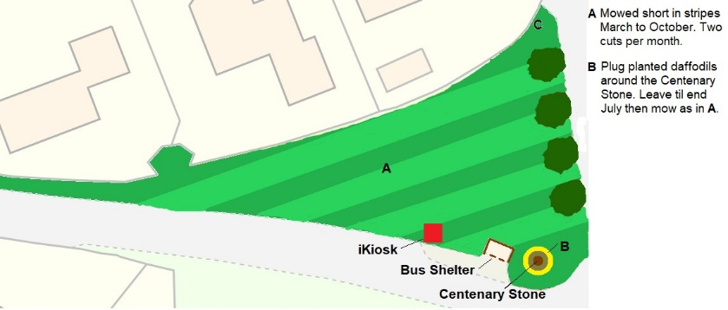
Wildflowers
The proposal to adjust the maintenance regime of the village green to include sections of wildflowers met with almost as much opposition as it received support.
The diagram to the right (fig 1) shows how the green is currently maintained.
Fig 1

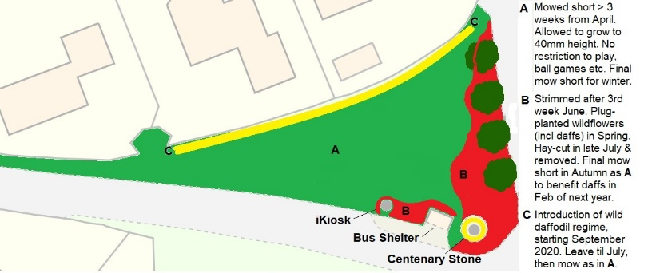
A proposal for an alternative maintenance regime to include a section of wildflowers has been put forward by DyFRA as illustrated in the diagram to the right (fig 2).

Fig 2

Proposed resolutions
- That the village green continue to be managed as a formal public open space suitable for community events and the current mowing regime be maintained;
- That permission be granted for wild daffodils to be introduced by volunteers in a 30cm band directly around the Centenary Stone and Bus Shelter and along the northern boundary of the village green (post the installation of Gigaclear fibre optic cables in autumn 2021) and that such areas be left uncut until end July to encourage their establishment.

Christmas Tree
Feedback from the community shows considerable support for a Christmas tree on the village green.
Tree
For Christmas 2020 DyFRA has offered to donate a 14ft living tree. Ricky Goodwin and Pitman Building have volunteered to concrete an 8 to 10-inch pipe into the green free of charge. The pipe would be covered with a custom-made cover with a manhole type key when not in use. Ricky will also arrange for a telehandler and cherry-picker with a cage to place the tree in the prepared hole and assist in decorating it. He has the necessary licences to operate these vehicles.
Lights and decorations
Three strings of multi-colour battery operated timer fairy lights containing 600 LED lights each can be purchased from www.realchristmastrees.co.uk at a cost of £30.00 each incl VAT. A further £60 should be sufficient to purchase decorations.
Proposed resolutions
- That a Christmas tree be erected on the village green annually from the last weekend in November to the weekend after 6 January with authority for the safe installation and removal of the tree delegated to the Clerk.
- That the Clerk be authorised to purchase lights and decorations for the Christmas tree up to a maximum value of £150 (applicable only to the 2020/21 financial year).

