You are invited to attend Kempley’s Annual Parish Meeting
on Thursday 30 May 2019 at 7:30pm in Kempley Village Hall

The meeting will be facilitated by Bob Earll.

Refreshments and cake from 7:00pm

AGENDA

Start 7:30pm

- Introduction and welcome by Chairman Martin Brocklehurst
- To receive apologies for absence
- To approve the minutes of the Annual Parish Meeting held on 25 September 2018.
- To receive a report from County Councillor Will Windsor-Clive
- Village Hall Refurbishment: Report from Cllr David Spencer on progress to date and potential funding options
- Broadband: Report from Cllr Martin Brocklehurst on progress to date
- Neighbourhood Watch: Report from Jill Croxall, Forest of Dean District Chairman, on Neighbourhood Watch
- To receive reports from Parish Organisations & Community Representatives
  - Windcross Paths Group
  - Dymock Forest Rural Action (Chris Bligh)
  - Friends of Kempley Churches (Howell Rees)
  - Kempley Produce Market (Maggie Bligh)
- Submissions, questions and proposals from Parishioners
Close 9:30pm
The Parish Meeting is an opportunity for parishioners on the Electoral Roll for Kempley to raise any matters of concern to them that relate to their local community. It would be helpful to have written notice of any matters to be raised but it is not essential. Matters can be raised at the meeting without prior notice. For any queries, please contact the Clerk to the Parish Council (Mrs Arin Spencer – Mobile: 07484619582 / Email: kempleyparishclerk@gmail.com)
Written reports (including Parish Council Accounts up to 31st March 2019) are available on the website.
All presentations/reports are subject to confirmation.
The order in which the presentations/reports are to be given is subject to change.
Martin Brocklehurst
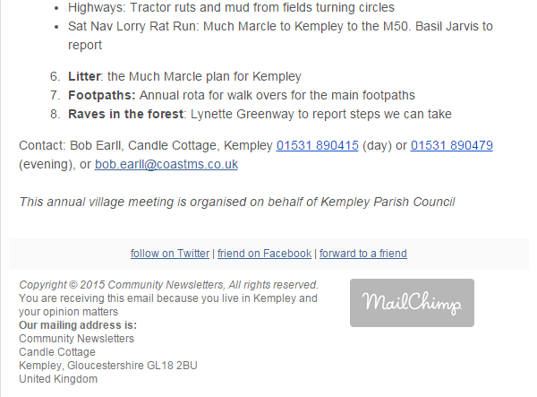
Chairman, Kempley Parish Council

