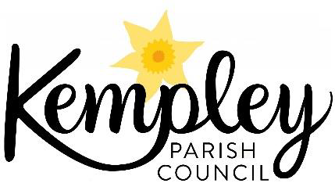
Kempley Parish Council - Climate Change Emergency
Report on progress to the May 2021 Parish Council Meeting.

Introduction
Kempley Parish Council declared a Climate Change Emergency at our meeting on 01st October 2019. We agreed at our November 2020 meeting that Kempley Parish Council would move forward towards carbon neutrality by 2030 by taking the following actions:
- Baselining our current community carbon emissions
- Showcasing best examples of carbon reduction programmes
- Promoting the uptake of existing grant schemes that will support carbon reduction
- Promoting the full uptake and use of superfast broadband [to drive change in the way we work, travel and shop to reduce carbon emissions].
Progress Report
We have made the following progress on our four key target areas;

- Baselining our current community carbon emissions –
Exeter University supported by the Centre for Sustainable Energy (CSE); the Department for Business Energy and Industrial Strategy, Nottingham City Council and Energy Hub (a small energy supplier), have released their software package IMPACT – A community carbon calculator - impact-tool.org.uk/ Using this tool, which provides a baseline carbon assessment for Parishes across England, we now know what the carbon footprint is for Kempley. The footprint is measured in two ways:
- territorial carbon emissions, based on carbon emissions from all economic activity taking part in the Parish; and
- consumption carbon emissions that result from residents’ consumption of manufactured goods, food and their own transport activity, regardless of where the emissions occur.

The two methods produce the following baseline carbon estimates:
Territorial Emissions:
- Per Household – 64.2 tonnes carbon dioxide equivalent (CO₂e)
- Total – 8,025 tonnes CO₂e
Consumption Emissions:
- Per Household - 25.1 tonnes CO₂e
- Total – 3135 tonnes CO₂e

A full breakdown of the numbers is shown in Annex 1.

Both measurements are based on national data sets and do not reflect local activities already taken by local parishioners and businesses to reduce their carbon footprint. We have many stories (yet to be told) of local parishioners taking substantial activity to reduce their carbon footprint. In other words we are already someway to reducing our carbon footprint. Once we understand what is happening locally, we can factor these reductions into the estimate of our carbon footprint.

Whilst parishioners may not be interested in these detailed numbers, they are important for the Parish Council to help in decision making on how we use our very limited resources. We have set out to make a material difference - that is we want to significantly reduce our carbon footprint in line with Government and Forest of Dean District Council targets. That is to reduce carbon emissions by 78% by 2035 (based on 1990 levels) and to make the District Carbon neutral by 2030.

To make these changes we need to influence the big carbon emissions from our community to make a difference. The big emission sources of carbon in our community are:

- Farming – carbon from farming is 65% of our territorial emissions;
- Housing – carbon from our homes is 15% of our territorial emissions;
- Housing – carbon from our homes is 38% of our consumption emissions;
- Goods and services – carbon from our consumption of goods and services is 25% of our consumption emissions;
- Travel – carbon from our travel is 21% of our consumption emissions;
- Food & Diet – carbon linked to the food we eat is 15% of our consumption emissions
It therefore makes sense to concentrate on working with our farming community to reduce territorial emissions and with homeowners to reduce consumption emissions as the two most important carbon reduction areas of activity.

- Showcasing best examples of carbon reduction programmes –
2.1 Sharing the Benefits
The Parish Council has asked Bob Earll and Mark Warrilow to develop an initiative with Kempley residents. The Sharing the Benefits initiative will explore resident’s response to the climate, over-consumption and nature emergency. There are many benefits that result from taking personal action and sharing these is a positive and constructive way to respond. Starting in May 2021 and continuing until July conversations are planned with residents about their views. For more information on this contact bob.earll@coastms.co.uk

2.2 Joining forces with local Parish Councils
We have joined forces with 9 other Parish and Town Councils to share best practice and to pool ideas on joint projects. Full details on the partner Parish Councils and links to their activities can be found in Annex 3
The group will next meet during May 2021 and continues to share ideas on how Parish and Town Council can make a difference. Parish Cllrs are welcome to join these online meetings.

2.3 Joining Forces with the Forest of Dean District Council
In addition we are working closely with the Forest of Dean District Council who declared a climate emergency in 2018. The District Council is now in the process of setting up a Climate Emergency Community Partnership that is expected to be active in the Autumn of 2021. Full details of the Forest of Dean activities can be found in Annex 4.

2.4 Centre for Sustainable Energy (CSE) – Local Communications Pilot on Climate Change.
CSE have provided material from the first four themes of their communications pilot to Parish Councils free of charge covering: Insulation of homes; Land management and connecting with the land; Reducing food waste, and Local travel. Full details can be found in Annex 2

As a Parish Council we have chosen not to actively use this material as we currently work through ideas on the best way to engage our community. (see Sharing the Benefits above) .

- Promoting the uptake of existing grant schemes that will support carbon reduction
As the Government Green Homes Grant Scheme has been scrapped no action has been taken on this area of work (see - https://www.theguardian.com/environment/2021/mar/27/uk-government-scraps-green-homes-grant-after-six-months
- Promoting the full uptake and use of superfast broadband –
Current Position
4.1 Kempley Airband Scheme – This programme, supported by the County Council Fastershire scheme went live on January 27th, 2016 and brought fast wireless-based broadband to micro businesses in Kempley. The scheme increased broadband speeds from 0.5-2 Mbps to 20 Mbps. It has expanded from the original 7 business partners to include additional business and residential users. Airband upgraded its services to all its customers in Kempley to 40Mbps, during the pandemic making it a key support for local businesses.
4.2 Kempley Combined Solution – In March 2021 Airband finished work to bring fibre to the premises in some of the most isolated locations in the north of the parish. The new service is now live and isolated farms and residential properties can connect to the service. It offers speeds of up to 250Mbps that will be crucial as more and more business activities go online. https://kempleyparishcouncil.org/wp-content/uploads/2020/03/200312_GD457_kempley-combined-doordrop_leaflet.pdf
4.3 Fastershire / Gigaclear; For the remainder of the village Gigaclear have confirmed they will attend the Kempley Parish meeting later in the year to brief Cllrs on proposals for installation 3Q 2021.
These three schemes are bringing reliable super-fast broadband to Kempley. Once it is fully installed it will provide opportunities to reduce our carbon footprint by:
- supporting home working and reducing the need to travel;
- supporting smart farming and precision agriculture that can deliver major carbon savings, healthier animals and reductions in inputs of fertilisers, pesticides and herbicides;
- supporting more efficient energy use in the home, maximising the use of renewable energy and reducing energy consumption;
- supporting better health monitoring and remote consultations.
See https://www.interact-lighting.com/global/iot-insights/the-iot-and-climate-change#:~:text=IoT-powered%20smart%20services%20and,facilitate%20another%203%20percent%20reduction.
Once installation is complete, we can explore future events on how to get the best benefits from the new systems and understand how we might reduce carbon emission as a consequence.
Martin Brocklehurst
Chair Kempley Parish Council – May 2021
Annex 1 Details of Kempley Parish Carbon Footprint
Kempley - Territorial Carbon Emissions per household (Territorial emissions are figures based on carbon emissions from everything going on in the Parish)
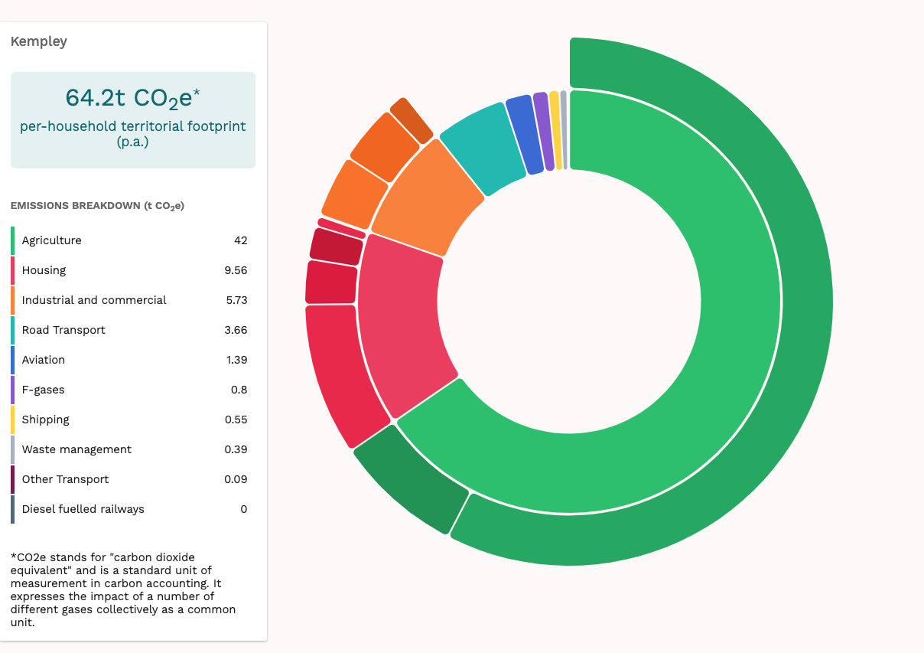
https://impact-tool.org.uk/footprint/footprint?parishId=E04004309&footprintType=territorial&scale=per-household&showSubCategories=true
Kempley - Territorial Carbon Emissions total
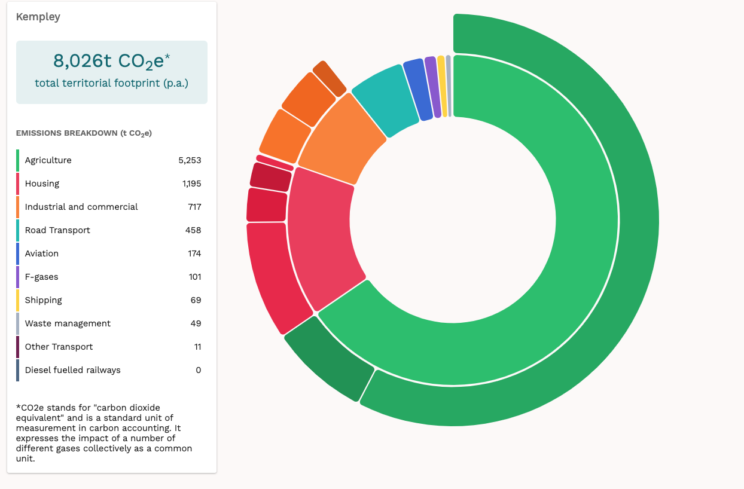
https://impact-tool.org.uk/footprint/footprint?parishId=E04004309&footprintType=territorial&scale=absolute&showSubCategories=true

Kempley - Consumption per household per annum (Consumption emissions are emissions from residents’ consumption of manufactured goods, food and their own transport activity, regardless of where the emissions occur).
https://impact-tool.org.uk/footprint/footprint?parishId=E04004309&footprintType=consumption&scale=per-household&showSubCategories=true

Kempley - Consumption - Total
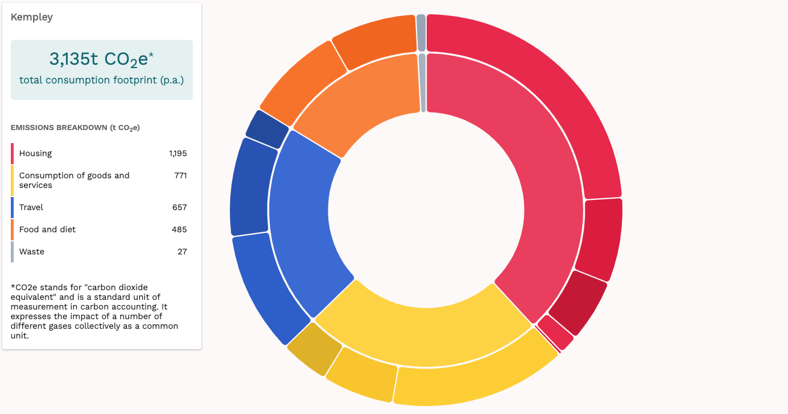
https://impact-tool.org.uk/footprint/footprint?parishId=E04004309&footprintType=consumption&scale=absolute&showSubCategories=true

Annex 2 Centre for Sustainable Energy (CSE) – Pilot Communications Scheme for Parish Councils – Major Topic Areas

December 2020 – Insulation of Homes - https://drive.google.com/drive/folders/18v6xKti8lDbjtYCi6S7TgyR7vpjnvZ7v

January 2021– Land Management and Connecting with the Land
https://drive.google.com/drive/folders/1j2ju31iMffgJvsTuI6Mq5exyk56hVl-1

February 2021 – Reducing Food Waste
https://drive.google.com/drive/folders/18ub2dqSe-EeqQLC4E3eMyY0qgx-NtgPf

March 2021 – Local Travel
https://drive.google.com/drive/folders/17NZ1KazdXBO6VZ0UOJ4avjs7vf5Ely8B

Annex 3 Partner Parish Council

- West Dean Parish Council - Climate Declaration:
https://www.westdeanpc.org.uk/wp-content/uploads/2019/08/WDPC-Climate-Emergency-Words-1.pdf
- Newland Parish Council – Climate working Group: http://www.newlandparishcouncil.gov.uk/_VirDir/CoreContents/News/Display.aspx?id=32856
- Westbury on Severn Parish Council - Website: https://westburyonsevernpc.org.uk
- Lydney Town Council – Projects:
https://www.lydneytowncouncil.co.uk/?page_id=1083
- Coleford Town Council – Website
http://www.colefordtowncouncil.gov.uk
- Cinderford Town Council – Website
https://www.cinderfordtowncouncil.gov.uk
- St Braviels Parish Council – Website
https://www.stbriavels-pc.gov.uk
- Linton Parish Council (Herefordshire) – Climate Working Group
https://lintonpc-herefordshire.gov.uk/climate-page-working-group/

Annex 4 – Partner - Forest of Dean District Council

Forest of Dean Declaration of Climate Change Emergency - see
https://www.climateemergency.uk/blog/forest-of-dean-district-council-becomes-the-first-rural-council-to-declare-a-climate-emergency/

Forest of Dean Road Map to a carbon neutral District by 2030
The District Council have set out a road map for the District to become carbon neutral by 2030 and details can be found at https://www.fdean.gov.uk/environment/climate-action/our-route-to-carbon-neutral/
Forest of Dean Climate Emergency Community Partnership
The District Council now plan to set up a Climate Emergency (CE) Community Partnership by the Autumn of 2021 to support activity in the District in line with the aspiration to be carbon neutral by 2030

The currently evolving partnership model
Full details on the draft Terms of Reference for the Community Partnership can be found at:
https://www.fdean.gov.uk/media/ynrmohxp/fod-ce-community-partnership-suggested-mission-and-tor.pdf

Forest of Dean as a partner in the AURORA EU Project
Kempley Parish Council has supported the District Council and the Centre for Sustainable Energy as partners in the EU Horizon 2020 funding bid for project AURORA and await to see if this European wide Energy Awareness Project bid is successful in attracting funds to support efforts locally to move to carbon neutral

----------------END------------------

