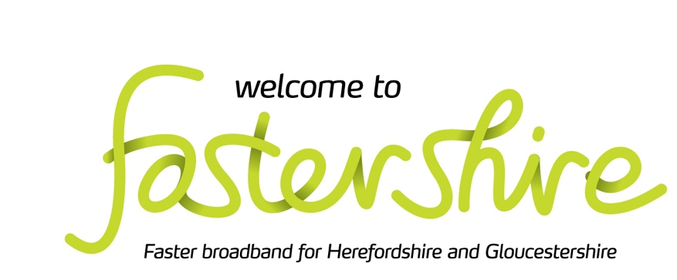

Kempley Parish Council – May 2022 Annual Parish Council Meeting

Community Broadband Grant – Kempley Project
Fastershire and Gigaclear de-scoped the Parish of Kempley during Christmas 2021 from the current programme to deliver fibre to the premises within the parish leaving Kempley cut-off from the new rural superfast broadband. This decision was taken by Fastershire for cost cutting reasons with no consultation with the Parish.

Following further consultations with Fastershires we have now concluded discussions about a new Community Broadband Grant - the Kempley Project, that has the potential to rectify the earlier decisions and achieve our goal of fibre to the premises for every property within the parish of Kempley. The proposed boundary of the Kempley Project will also include outlying properties close to Kempley as follows:

- the Dymock road as far as and including the Old Rock Farm in the parish of Dymock;
- the B4024 as far as Hill Grove and all adjoining properties in the parish of Dymock;
- the C class road from Kempley as far as Daubies Farm and adjoining properties;
- the C class road from Kempley as far as Castle Farm and Upton Court;
- the C class road from Kempley to Much Marcle as far as Awnells Farm and adjoining properties;
- parts of the Parishes of Yatton, Upton Bishop and Much Marcle as far west as Yatton Wood and including Welsh Court, Deans Place, Perrystone Hill, Lynne Down, Bodenham Bank and Bickerton Court.
A map of all the properties currently included is attached in Appendix 1.

Details of the Scheme Community
The purpose of the grant is to seek a solution for properties without access to a superfast connection (30mbps or above). The scheme seeks to invest in networks that are capable of providing access to gigabit connections (1,000mbps), Fibre to the Property. The solution may mean using a new supplier or different technology to reach a deeply rural community, or to extend an existing network further to reach outlying properties that were too expensive to connect in previously.

How does the grant scheme work?
Fastershire have confirmed that the scheme will operate as follows:
- Step 1: Individual residents and businesses will submit their Expression of Interest
- Step 2: When there is sufficient interest from an area, Fastershire will bring these requests together to form a ‘community’ project
- Step 3: Fastershire will support the ‘community’ to develop the formal ‘Request for Quotation’ (RFQ) which will be published on the grant’s online procurement portal
- Step 3: A range of potential broadband network suppliers will then have 28 days to view the RFQ and submit bids for the contract
- Step 4: Fastershire will evaluate the received quotes and will make a formal recommendation to the community
- Step 5: The contract will be specific to that community and will be awarded by the community to the chosen supplier
- Stage 6: When the network is built, Fastershire will release payment to the supplier when community members confirm the network has been delivered and they are able to place their broadband order.
A few things worth knowing
Properties with a 4G solution, are still able to sign up for the Grant.
No one is asked to break an existing contract, simply to join the new service when his or her current contract comes to an end.
If we secure a contract with a supplier, it is likely to take a minimum of 18 months before a service will be available.
When the copper lines are phased out fibre offers a reliable, high-speed broadband connection.
The grant funds the installation of broadband infrastructure to an individual property.
The end user is responsible for the final cost of the connection into the home, which current providers estimate will cost £0-£99 and the monthly subscription for the internet service.

To register for the Community Broadband Grant
To be able to take advantage of the Community Broadband Grant eligible properties will need to register. Only when we have sufficient interest in the scheme will we be able to progress. The exact percentage of properties that need to sign up is dependent on the final cost of the installation but as a Parish Council we should aim to encourage up to 75% of eligible properties to participate if we are to develop a successful scheme.
For a property to be included registration is required for the Community Broadband Grant. Full details can be found by using the address checker function on the website www.fastershire.com Eligible properties can then proceed to register. Anyone with further questions, can contact, grants@fastershire.com

Recommendation
It is recommended that the Parish Council:

- Confirm formal support for the Kempley Community Project to Fastershire ;
- Request the Parish Council to liaise with Fastershires and the Parish Clerks in Dymock, Yatton, Much Marcle and Upton Bishop to set up a parish meeting at which full details of the scheme can be discussed with eligible local residents;

Martin Brocklehurst – Chair Kempley Parish Council

