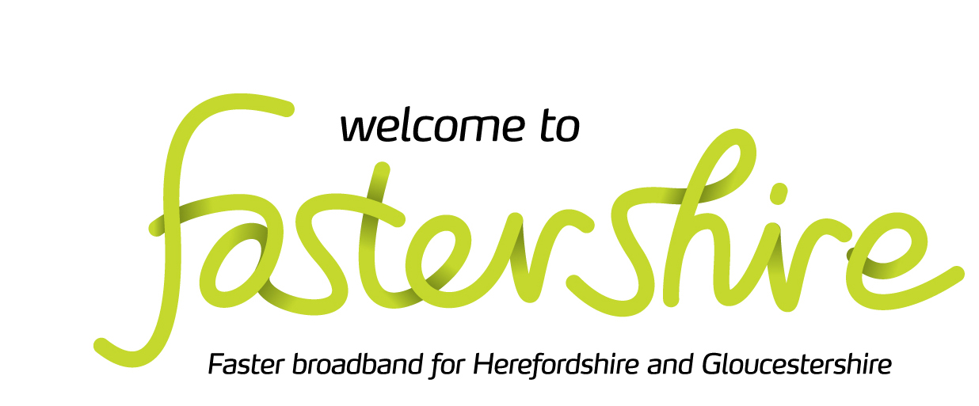

Community Broadband Grant – Kempley Project

This information is about the Community Broadband Grant scheme for hard to reach areas.

The purpose of the grant is to seek a solution for properties without access to a superfast connection (30mbps or above)
The scheme seeks to invest in networks that are capable of providing access to gigabit connections (1,000mbps), Fibre to the Property.

In some cases, the solution may mean using a new supplier or different technology to reach a deeply rural community, or to extend an existing network further to reach outlying properties that were too expensive to connect in previously.

How does the grant scheme work?

- Step 1: Individual residents and businesses will submit their Expression of Interest
- Step 2: When there is sufficient interest from an area, Fastershire will bring these requests together to form a ‘community’ project
- Step 3: Fastershire will support the ‘community’ to develop the formal ‘Request for Quotation’ (RFQ) which will be published on the grant’s online procurement portal
- Step 3: A range of potential broadband network suppliers will then have 28days to view the RFQ and submit bids for the contract
- Step 4: Fastershire will evaluate the received quotes and will make a formal recommendation to the community
- Step 5: The contract will be specific to that community and will be awarded by the community to the chosen supplier
- Stage 6: When the network is built, Fastershire will release payment to the supplier when community members confirm the network has been delivered and they are able to place their broadband order

A few things worth knowing
If you have a 4G solution, you are still able to sign up for the Grant.
We do not ask anyone to break an existing contract, simply to join the new service when his or her current contract comes to an end.
If we secure a contract with a supplier, it is likely to take a minimum of 18 months before a service will be available.
When the copper lines are phased out fibre offers a reliable, high-speed broadband connection.
The grant funds the installation of broadband infrastructure to your property.
The end user is responsible for the cost of the connection into your home, which our current providers cost in at £0-£99 and the monthly subscription for the internet service.
To register for the Community Broadband Grant

If you would like your property to be included in the Grant, please register for the Community Broadband Grant, use the address checker function on the website www.fastershire.com

If you any questions, please contact us, grants@fastershire.com

Yours Faithfully,

Gemma Johnson.
Senior Project Manager

