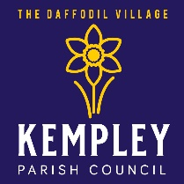 | Calling Kempley’s  Community Champions

Kempley Parish Council is small with a tiny precept but continues to secure funding to benefit our village. If you want to join us and serve your community, we would love to hear from you. It’s a small commitment to make as we meet just 7 times a year.

Would you like to make a difference and shape the future of your community?

Do you have concerns about issues in the local area?

Do you feel your views aren’t currently represented?

Then please consider becoming a Parish Councillor.

For more information on becoming a councillor go to: https://www.nalc.gov.uk/makeachange
or contact: clerk@kempleyparishcouncil.org.

