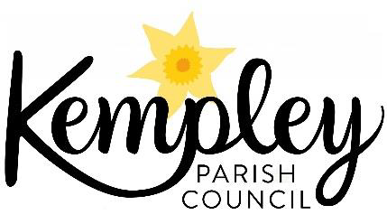

Kempley Parish Council - Climate Change Emergency

Report on progress to the May 2023 Parish Meeting.
Kempley Parish Council (KPC) declared a Climate Change Emergency at our meeting in October 2019. We later agreed that the KPC would move forward towards carbon neutrality by 2030 by taking the following actions:
- Baselining our current community carbon emissions
- Showcasing best examples of carbon reduction programmes
- Promoting the uptake of existing grant schemes that will support carbon reduction
- Promoting the full uptake and use of superfast broadband [to drive change in the way we work, travel and shop to reduce carbon emissions].

Action 1 - Baselining our current community carbon emissions - Work Complete
Progress – Improving our understanding on where the greatest potential exists to reduce carbon emissions and costs from home heating and energy use.

We have completed work to understand our baseline carbon emissions and where we sit in relation to the other Parishes in the Forest of Dean taking data from the IMPACT Tool on all local Parishes (see below)

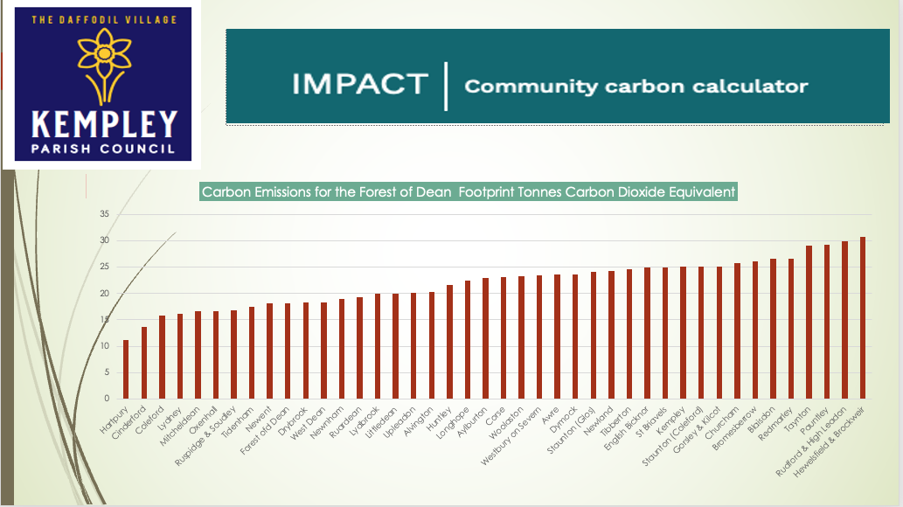

Data has also been collated on the Energy Performance Certificates (EPC) for Kempley. 70% of properties in Kempley have an EPC. 49% of properties in our community has the poorest EPC performance ratings of EFG. This is worse than the average for the Forest of Dean at 31%
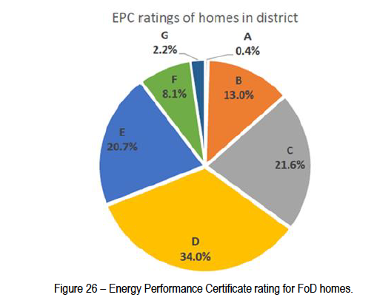. 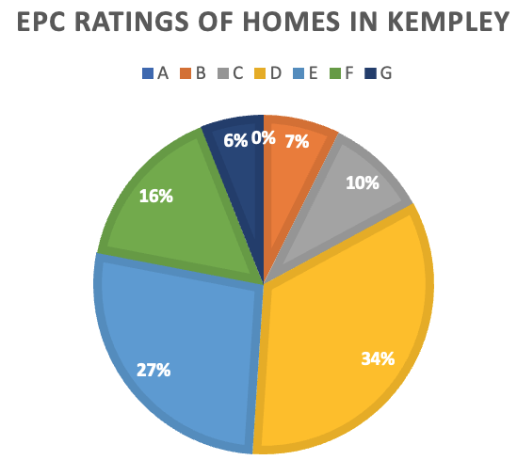
This data provides a clear list for residential property in Kempley where the greatest financial savings and carbon reductions can be achieved.

The data for the Forest of Dean was taken from a report submitted as a key output for the AURORA project exploring business plans to create a community solar energy scheme at the school and leisure centre in Lydney.

It illustrates that great opportunities exist in Kempley to improve the insulation of our homes and farms to reduce expenditure and carbon emissions.

Actions 2 & 3 Promoting exchange of information on best practice and existing grant schemes that will support carbon reduction and help people reduce costs during the energy crisis.
Major Progress
Kempley Parish Council continues to communicate and exchange ideas with other Parish and Town Councils on how to encourage communities to reduce their carbon footprint and achieve levels recommended by the Paris Commission. It is clear that such action is necessary as 30% of carbon emissions are created from heating, and powering our homes and from the transport decisions we all take. Actions to save carbon are also now a great way to reduce costs. The Parish Council takes part in regular discussions and exchanges ideas with the:
- EU AURORA Project see https://www.aurora-h2020.eu and attends local meetings concerning the Forest of Dean pilot project;
- Forest Climate Network which represents Town and Parish Council across the Forest of Dean District Council area;
- Gloucestershire Association of Parish & Town Councils (GAPTC)
- Gloucestershire County Council Climate Change Programme

The Parish Council also supported a community event organised by Bob Earll.
A successful “Can Do Café” on Home Energy which was held at the village hall on October 29th 2022 to learn and share experience
This was designed to promote peer to peer exchange of experiences learnt in our community on how we can all tackle the energy crisis, save money and
carbon. The event was sponsored by both Newent Transition, Kempley Parish Council and the Kempley Village Hall Trust.

We now know that the Forest of Dean is in the top 10 Local Authorities in England and Wales to take advantage of the Government Boiler Upgrade Grant Scheme. It is still a small percentage of properties across the Forest of Dean but it is an encouraging start.
Action 4 - Promoting the full uptake and use of superfast broadband
Latest Position – On the cusp of success
The Parish Council has worked with Fastershire (the joint Gloucestershire and Herefordshire County Councils programme to bring superfast broadband to remote rural areas) and put in place the Kempley Community Broadband Scheme to bring fibre optic broadband to our community. Covering Kempley, parts of Dymock, Much Marcle, Upton Bishop, Much Marcle and Yatton and with the support of volunteers, we have secured over 70% participation rates. FULL FIBRE were confirmed as the successful contractor to undertake the installation work which is scheduled to start this summer with a completion date early 2024.

Next Steps – Join the AURORA Pilot

Next steps are to map improvements that have been achieved in the village and to encourage parishioners to join the AURORA Forest of Dean pilot being run by the Forest of Dean District Council and the Centre for Sustainable Energy Bristol. The pilot will provide:
- Opportunities to join a local Community Energy Scheme and to invest in community solar schemes locally through the Big Solar Co-operative. A return on capital invested and offset allowances against your carbon footprint will follow:
- To use the AURORA Telephone APP – rather like a personal trainer to assist you to save money and reduce your carbon footprint. This will include giving you tailored advice for your own personal circumstances; and
- Provide you with an overall assessment through a carbon labelling scheme to see how you are doing compared to others in the Forest of Dean.

You will have a unique opportunity to join the pilot in the Forest of Dean as this is the only such pilot in the UK

Martin Brocklehurst
Chair Kempley Parish Council – May 2023

