KEMPLEY PARISH COUNCIL Asset Condition Report as at 17th August 2023 Completed by: Tim Dain (Clerk)
Asset Description | Location | Condition | Comments | Photographs
Village Green | Kempley Green | Good | Need to seek tenders for 2024 maintenance contract | 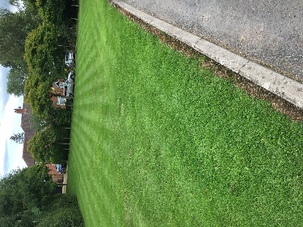 |  | 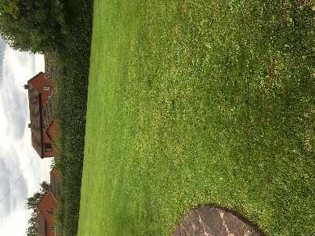
Bus Shelter | Kempley Green | Good |  | 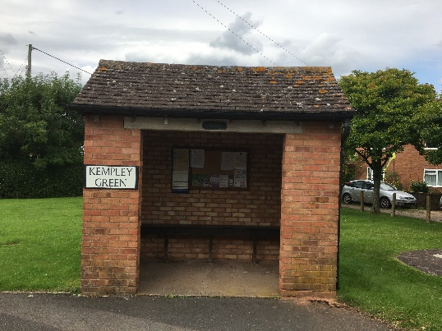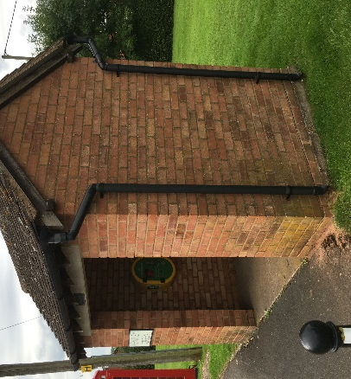
Bus Shelter | Fishpool | Good | Vegetation to back and side needs to be trimmed back. | 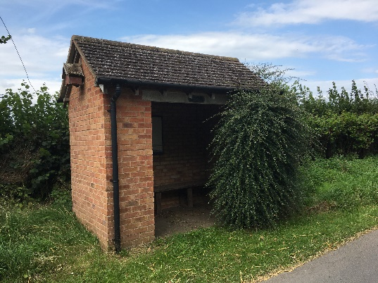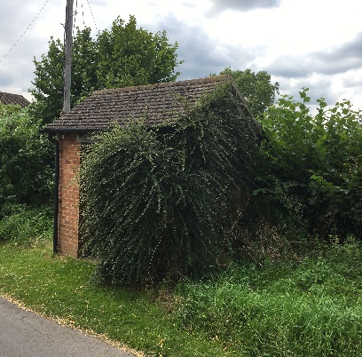
iKiosk | Kempley Green | Good |  | 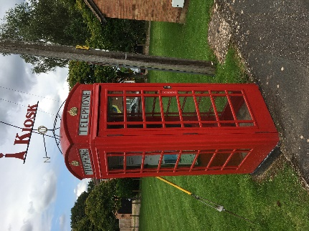
Defibrillator | Kempley Green | Good | Pads expire 2024 | 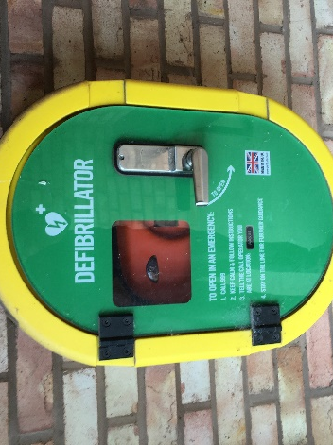
Defibrillator | Village Hall | Good | Pads expire 2024 | 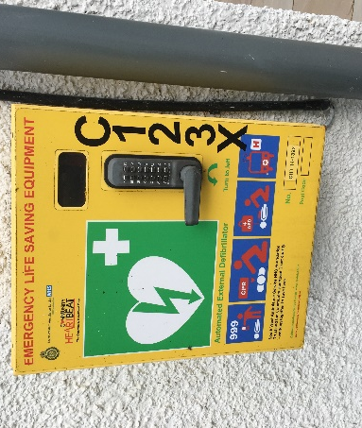  Code to open defibrillator now shown and is available from Ambulance Control
Defibrillator | Fishpool | Good | Pads expire 2024 | 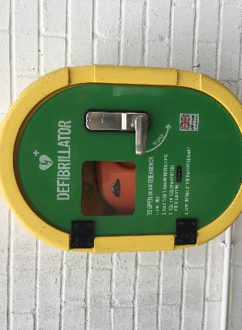
Flagpole | Kempley Green | Acceptable |  | 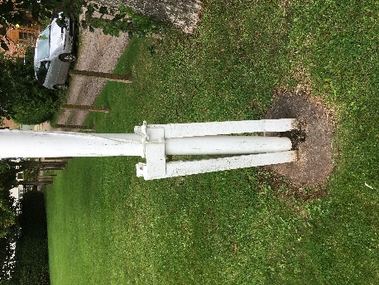 |  | 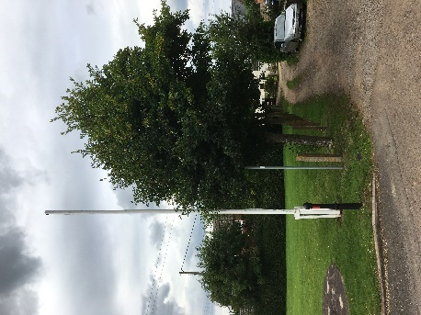
Noticeboard | Kempley Green Bus Shelter | Acceptable |  | 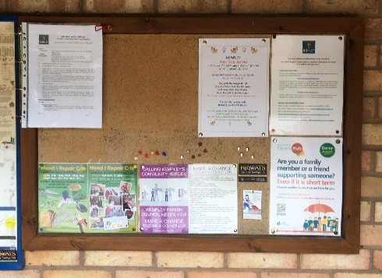 |  | 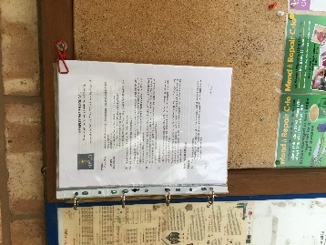
Noticeboard | Fishpool | Approaching end of life |  | 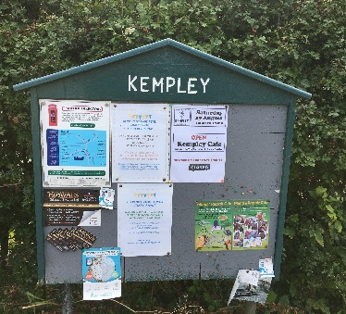
2014 Memorial Stone | Kempley Green | Good |  | 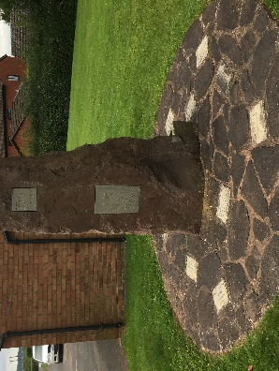
Dell Laptop Serial No:  33067535547 | Clerk’s home | Excellent | McAfee virus protect added July 2023
Rexel Laminator | Clerk’s home | Excellent |  | 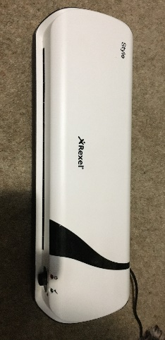
Filing Cabinet | 4 drawer lockable filing cabinet | Acceptable |  | 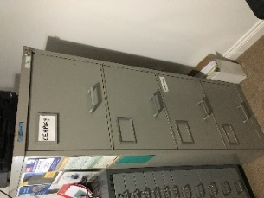
Traffic Signs: 20 is Plenty | Trying to locate |  | Not inspected
Neighbourhood Watch signs | Location unknown |  | Not inspected
Traffic signs: Welcome to Kempley | Various | Good | 5 in situ | 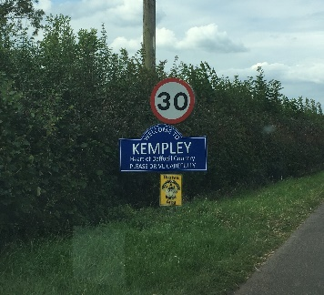 | 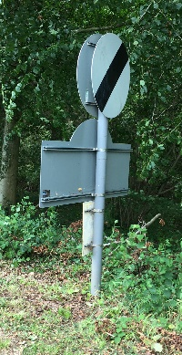
Gazebo | St Ed’s Church storeroom | Good | Purchased 2022 on behalf of Daffodil Committee from BBF Grant
Gas Barbeque | Village Hall storeroom | Good | Purchased 2022 on behalf of Daffodil Committee from BBF Grant

