Chairman’s Briefing Paper
Parish Council Meeting - 20th November 2023

Item 137 – Kempley Community Broadband Scheme
FullFibre commenced installation work in September 2023. A short press release was issued on 23rd September (see attached) and a commemorative photograph was taken on the Kempley Village Green involving local residents, Full Fibre and Fastershire. The story was told on the Steve Kitchen show (BBC Local Radio) and was reported in the local papers.

Work commenced at Phocle Green with the installation of aerial fibre optic cables. Since that date work has taken place across the full area of the Community Scheme and series of road closures have been advertised to allow the installation of aerial fibre optic cables, new telegraph poles, and conduit road crossings. FullFibre have been extremely helpful as work has progressed and have met with local businesses in Kempley to ensure access through the road closures for milk tankers and other HGVs delivering critical farm supplies.

Discussions over way leave routes to connect isolated properties have so far been successful. No property has been descoped so far as a result of escalating costs. FullFibre have successfully supported an application to vary a planning condition that would have prevented aerial fibre optic cables connecting a property in Kempley. A decision was also taken to install both the aerial fibre optic cables and external connections to properties at the same time, to reduce the need for multiple road closures. Details were communicated to local residents taking part in the scheme.

Further publicity is planned to celebrate the first resident to be connected with a working broadband connection. This is expected to take place before Christmas and may well be in the Yatton area. Further publicity is being planned with discussions about a short film to celebrate bringing superfast broadband to our remote communities. The film will explore the work the community put into achieving the current success and the impact superfast broadband will have on the lives and businesses of local people.

The project remains on schedule for completion by March 2024.

Item 138 – Update on Kempley Parish Council Climate Change Plan

- Background Kempley Parish Council Policy on Climate Change

Kempley Parish Council (KPC) declared a Climate Change Emergency at our meeting in October 2019. We agreed at our November 2020 meeting that the KPC would move forward towards carbon neutrality by 2030 by taking the following actions:
- Baselining our current community carbon emissions
- Showcasing best examples of carbon reduction programmes
- Promoting the uptake of existing grant schemes that will support carbon reduction
- Promoting the full uptake and use of superfast broadband [to drive change in the way we work, travel and shop to reduce carbon emissions].

- Kempley Parish Council – Progress on a core work programme

Since Kempley Parish Council declared a climate emergency and laid out a work plan to reduce carbon emissions in the Parish, both the FODDC and Glos CC have become active in supporting work to address Climate Change. We can therefore work closely with these organisations and the EU Funded Aurora Project – Tackling Climate Change, to achieve our goal of reaching net zero carbon for the Parish by 2030. Full details on these programmes are outlined in Appendix 1.

The following section updates progress and suggested next steps on the work programme put in place in 2020.

  - Baselining our current community carbon emissions
This piece of work is completed.– see Appendix 2.

It is proposed we now take on a second phase to monitor improvements in our carbon emissions and track progress towards net zero carbon for the Kempley Parish Community.

We know that to reduce our carbon emissions to net zero by 2030 it will be critical to tackle emissions from housing, farming and transport. We have not yet put in place a system to measure improvements that farmers achieve as they change the way they run their farming businesses and parishioners achieve as they change the way they heat and power their homes. We have also not put in place any systems to record changes that follow as our community switches to electric vehicles.

Next Steps
- With both the FODDC and Glos CC taking positive action to measure progress towards net zero carbon by 2030 it is proposed that we adopt a similar approach for Kempley Parish and co-operate with the FODDC to apply that methodology to Kempley Parish.

- The FODDC EU AURORA Pilot Project has now released the AURORA Energy Tracker app for citizens to use to track changes to their personal carbon emissions from heating, lighting and transport. It is proposed that we promote the uptake of the AURORA Energy Tracker in Kempley and encourage parishioners to use the APP through the local WHATS APP Group.

- We have already agreed to Set up a data layer on Parish Online where activity to reduce carbon emissions across the Parish can be plotted. Examples include ground source heat pumps, solar panels, air source heat pumps, wind turbines, anaerobic digesters etc. This action is outstanding due to resource constraints. It is recommended we seek a volunteer to action this idea.

  - Promoting exchange of information on best practice and existing grant schemes that will support carbon reduction and help people reduce costs during the energy crisis.
We have completed initial action to deliver these two objectives with the support of Bob Earl who ran a Community Café in October 2022 covering Home Energy – Learn and Share. Clearly we need to continue to make local residents aware of best practice and changing grants, but we can do this by promoting advice and guidance that is now available from both the FODDC and Glos CC.

Next Steps –
- Promote the advice and guidance given by the FODDC, Project AURORA and Glos CC on best practice and grant schemes to reduce carbon emissions via the Parish Council Whats App Group;
- Encourage local residents and business owners to sign up to receive Newsletters produced by the FODDC, Project AURORA and Glos CC on Climate Change.

  - Promoting the full uptake and use of superfast broadband [to drive change in the way we work, travel and shop to reduce carbon emissions].
Work is now underway to complete the Kempley Community Broadband Scheme. With full commissioning planned for end March 2023 further work should be focused on ensuring the community gets the maximum carbon benefit from using the new capability of superfast broadband to its full potential.

Next Steps
- Promote the full uptake of superfast broadband and run funded training courses to illustrate the full potential of the internet for farming activities and for domestic and related work activities;
- Build case stories to explain the carbon benefit of changes to work practises and domestic behaviours from fully using the power of the internet;
- Fully explore the linkages of using the internet for health and social care services.

Appendix 1

Current Position – Local context for the work of Kempley Parish Council on Climate Change

A1. The Forest of Dean District Council (FODDC)
The Forest of Dean were the first District Council to declare a climate emergency.

A.1.1. Project AURORA – FODDC are leading a local pilot under the EU funded project AURORA -Tackling climate change. This project has set up a Community Energy Group for the Forest of Dean and a partnership with the Big Solar Co-operative to fund the very first community energy scheme on the roof of the Lydney Leisure Centre and the adjacent school. 40 other large buildings with high energy demand are under investigation for similar schemes. Smaller buildings with lower energy demand may be tackled through a second community energy programme run by the Gwent Community Energy CIC or through setting up a similar scheme for the Forest of Dean.

Kempley Parish Council has remained closely connected to project AURORA through the Chairmans declared interest in this EU funded project

As part of the local project AURORA pilot The Forest Community Energy Group scheme will allow our community to invest in shares in community solar energy schemes in the Forest of Dean in a partnership programme with the Big Solar Co-operative. Under the scheme Parishioners will be able to receive a rate of return higher than current bank investment rates. A crowd sources funding call is expected shortly to fund the first community energy scheme in Lydney. The building owners contract to buy power from the Big Solar Co-operative at rates below current electricity prices and a small profit flows back to the Big Solar Co-operative to fund the next scheme.

Kempley Parish Council has attended meetings of the Forest Community Energy Group through the Chairmans declared interest in this EU funded project

Project AURORA has also released the AURORA Energy Tracker, available for iOS and Android devices. This enables citizens to track their carbon emissions from heating, power, and transport. The system links to investments in the AURORA community energy schemes offering offsets for carbon emissions and measures performance against a community energy labelling scheme so they can measure how well they perform.

A1.2. Forest of Dean Community Climate Action Partnership (FODCAP) – To implement an action plan capable of delivering net zero carbon for the Forest of Dean the District Council have set up the Forest of Dean Community Climate Action Partnership. Project AURORA is a key component of this partnership covering energy and the move away from fossil fuels. FODCAP will also address other carbon sources from food and farming, encourage a change of attitude to travel and engage with local schools to support the programme as it emerges.
Kempley Parish Council Chairman attended the most recent meeting of FODCAP ensuring the work of the KPC was well understood.

A2. Gloucestershire County Council

Gloucestershire County Council declared a climate emergency in May 2019 and a commitment to get to net zero carbon by 2030. They have an implementation plan in place and issue a regular newsletter with advice to citizens on the actions they can take to reduce their carbon footprint. They also have a dashboard to measure progress and a link from the dashboard enables citizens to sign up for the newsletter. Tips for citizens on how to reduce their carbon footprint are also provided.

Kempley Parish Council can work with the Glos CC and target information campaigns direct to local residents with a free leaflet drop scheme

A3. Forestry England – Forestry England recently briefed communities across
the Forest of Dean on how they plan to change the management of their forestry estate as a result of changes in the local climate. These changes will affect Dymock Woods and the woodlands that make up their estate close to Kempley. They indicated that modelling suggests our climate will be more like the Loire Valley by 2030. This will require a change in the species mix of forest trees and a reduction in clear felling. Natural regeneration and underplanting will take place in future years. These aspirations are however tempered by an influx in new tree diseases arriving in the Forest of Dean as our climate warms. To minimise disease risks any diseased stock are being clear felled and this action cuts across the desired change to reduce clear felling in our woodlands.

Kempley Parish Council attended this meeting and will be able to distribute the Powerpoint presentation (when it is made available) to inform Parishioners on the expected changes to the way our local woodlands are managed.

A4. Forest Climate Network – Kempley Parish Council shares current progress on our work to reach net zero carbon by 2030 with other parish and town councils across the Forest of Dean through an informal networking group – the Forest Climate Network. The Chair of Kempley Parish Council currently attends regular on-line meetings to exchange best practice and learn from other Parish and Town Councils across the Forest of Dean.

Appendix 2 – Base Line Carbon Emissions – Kempley Parish
Our whole carbon footprint
This figure shows the annual carbon emissions (measured in tonnes) emitted as a result of the different ‘activities’ that residents within our parish’s boundary engage in – from heating to eating.
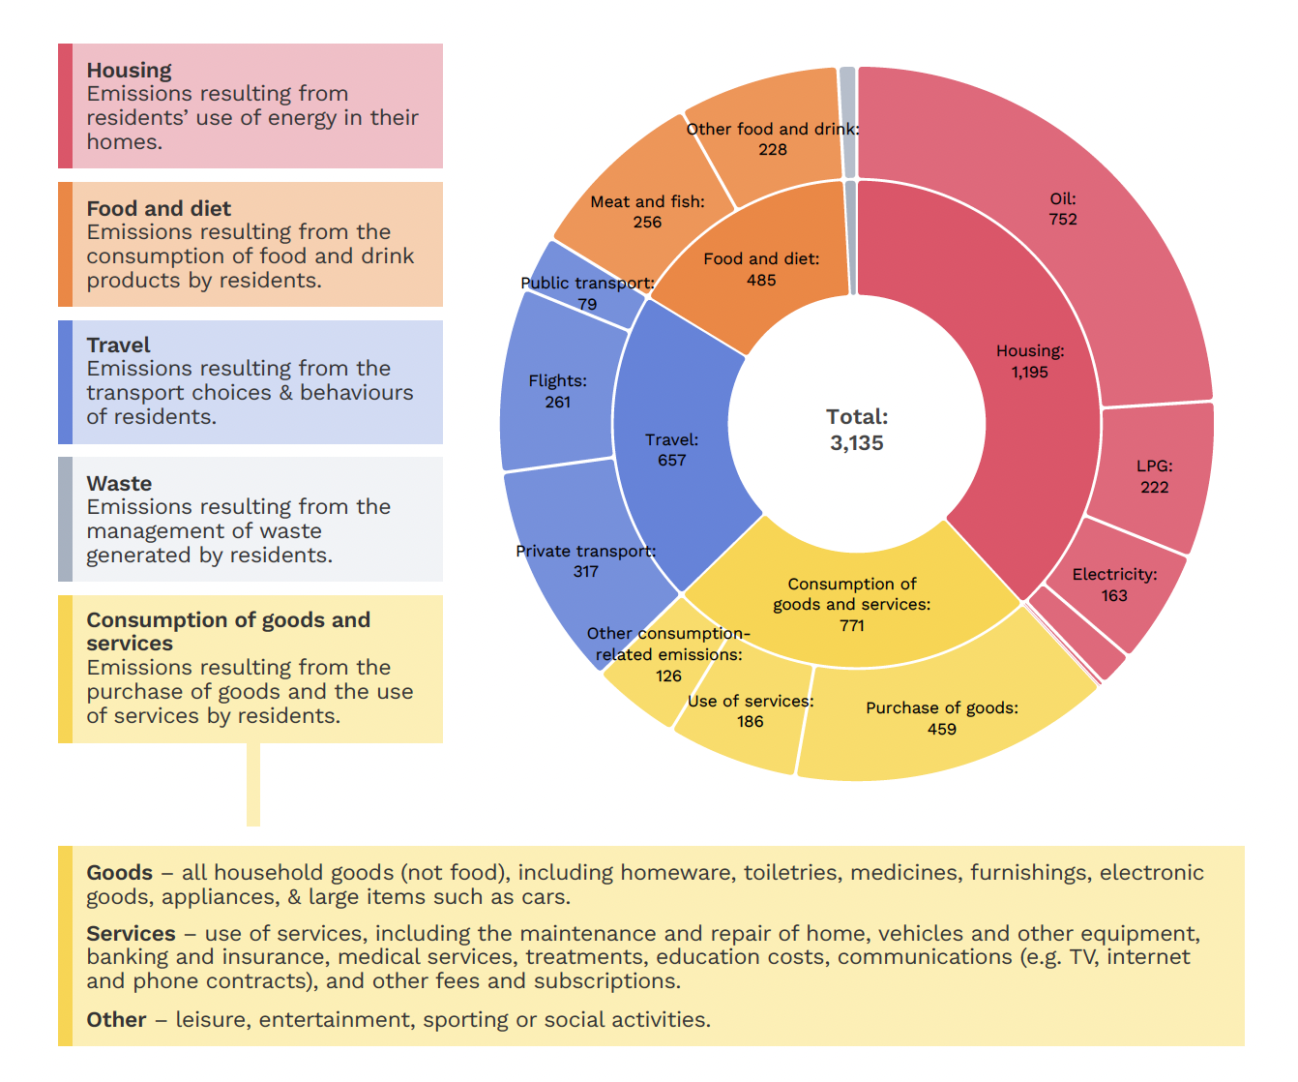

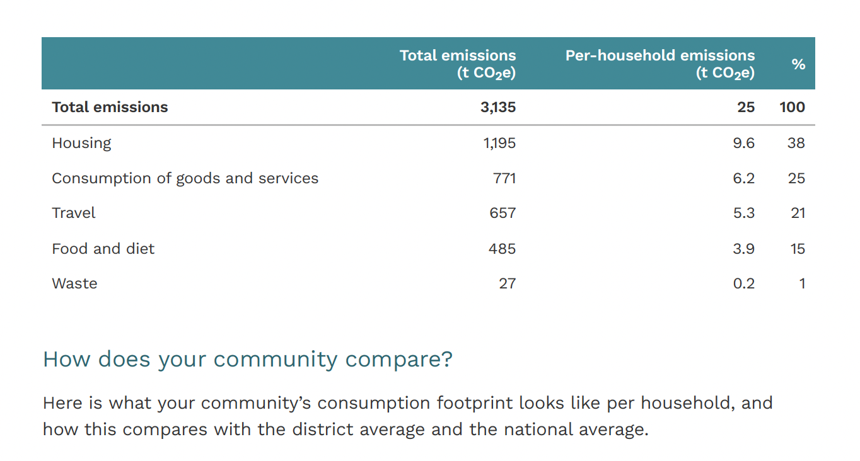

Our whole footprint
This figure shows the annual carbon emissions (measured in tonnes) emitted as a result of ‘activities’ taking place within our parish’s boundary.
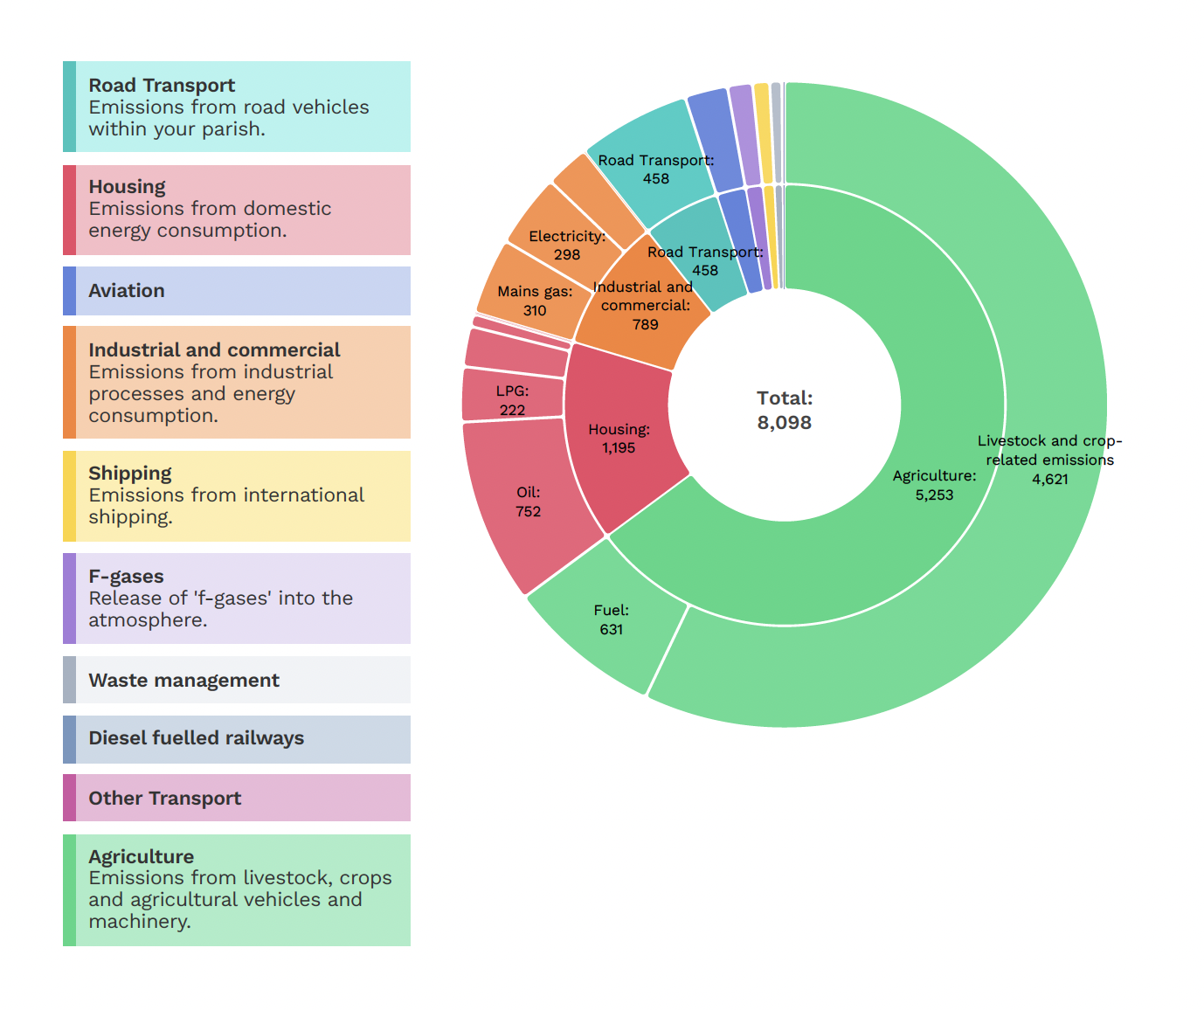

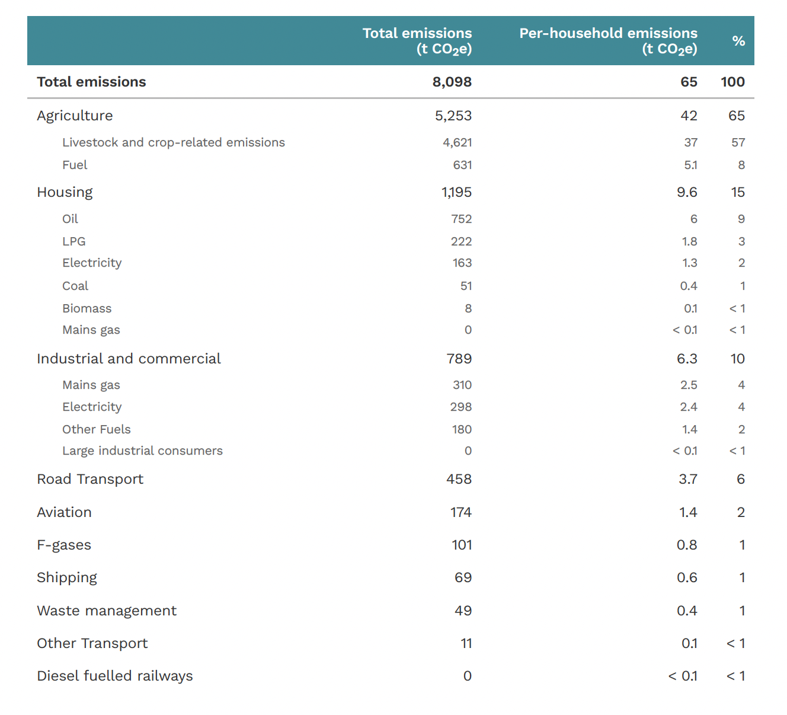

Item 139 Kempley Parish Council – Updater on Public Rights of Way (PROW)
Kempley Parish Council has continued to work with the Glos CC PROW Officers to improve public footpaths for both landowners and users by:
- Improving signage and awareness by users of the routes and the Countryside code;
- Changing stiles for kissing gates to reduce maintenance costs and allow more elderly people to use the footpaths;
- To re-open blocked footpaths;
- To divert public footpaths where that is in the best interests of landowners and users;
- To improve maintenance of our main footpaths and clear overgrowing vegetation from headlands and keep routes open when farm crops ,such as maize, are grown across PROW.
Stile Replacement
For 2022-23 we have planned a further round of stile replacements as follows:
- GKE 29 Boundary between Folly Farm and Matthews Farmland;
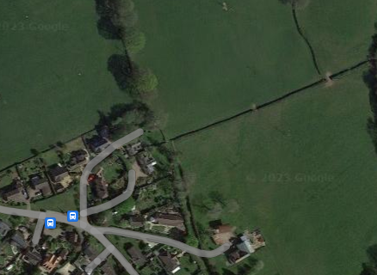
- GKE23 Hillbrook Farmland (boundary with the lane to Much Marcle);
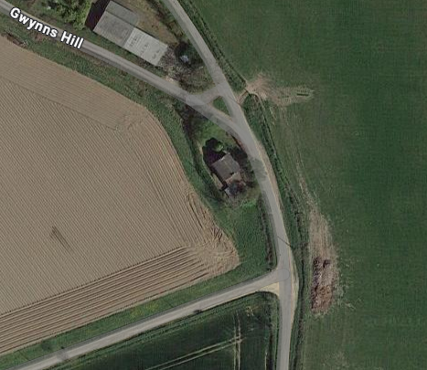
- GKE20 Boundary between Hillbrook Farm and Court Farm;
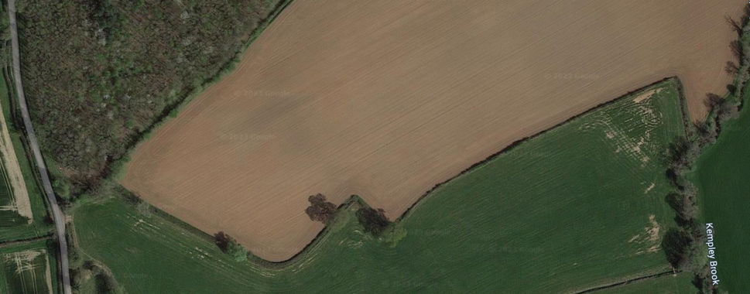
- GKE13 Stonehouse Farmland (completed)
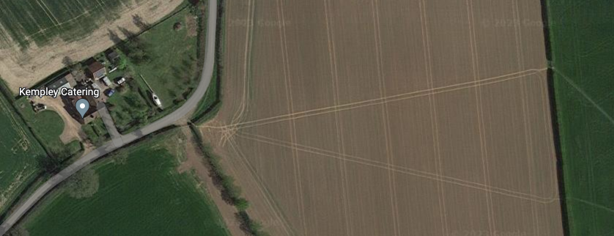

- We have permission for a further two stiles on land at Stonehouse Farm Cottages on GKE 11. This work is still to be agreed with the PROW officer,

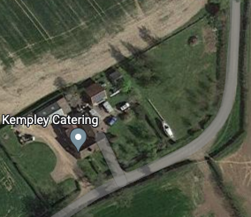

Blocked Footpaths
GKE38 Kempley Green

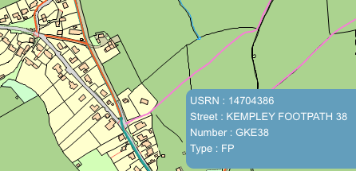
Work continues with the PROW Officer and the landowners to seek a diversion order for this blocked PROW.

GKE 21 On land owned by Matthews Farm and Court Farm

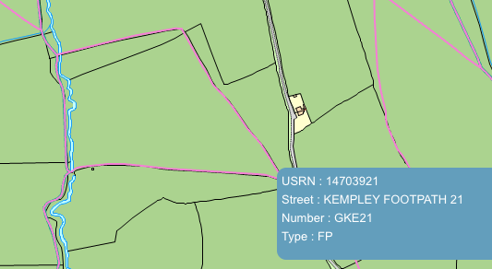

Work is planned to install a new footbridge over Kempley Brook and to open a blocked route through a hedgerow with a new kissing gate. This work will probably be delayed till 2024/2025.

